 | PubMed Expert Searching:  Using PubMed to Get Advanced Results



Updated: December 2007

Table of Contents

Agenda 2
Searching with MeSH 3
Basic Information about MeSH: 3
MeSH Particulars 4
MeSH Tree Structure 8
MeSH Browsers & Databases 15
OLDMEDLINE Citations 18
Automatic term mapping 20
Searching With Field Tags 24
Search Rules and Syntax 24
Search Field Abbreviations 25
Subset [SB] 37
Filter [filter] or [sb] 38
Discipline Searching 43
Veterinary Medicine Discipline Searching 45
Nursing Discipline Searching 46
Allied Health Discipline Searching 48
Pharmacologic Action Headings (PA) and Searching for Drug Information 50
Pharmacological Actions [PA] 52
My NCBI 55
Setting up a My NCBI account: 55
Setting Filters in My NCBI 57
LinkOut for Libraries and My NCBI 59
Saving Searches in My NCBI 61
Saving Collections in My NCBI 63
Preferences in My NCBI 66
LinkOut 66
Searching with Clinical Queries 68
Search by Clinical Study Category 68
Find Systematic Reviews 70
Medical Genetics Searches 71
Special Queries 71
Creating Web Links to PubMed 72
Searching 73
Formats 74
Date Ranges 74
Relative Dates 75

Agenda

Welcome, introductions, review of handouts 15 minutes
What do you hope to learn from this class?
What skills do you feel you need in order to become an expert searcher?

MeSH 60 minutes

Field Tags and LinkOut 30 minutes

Search Exercises with Field Tags 15 minutes

Break 15 minutes

Searching in Specific Disciplines 15 minutes

My NCBI 20 minutes

Clinical & Special Queries 20 minutes

Additional Tips and Tricks: Building Web Links 15 minutes

Wrap up and Evaluations 15 minutes

Searching with MeSH

Basic Information about MeSH:

- MeSH is an acronym for Medical Subject Headings. It is the controlled vocabulary used to index articles in MEDLINE and Index Medicus and it is used for cataloging books and audiovisuals.

- The home page for the MeSH section of NLM is located at http://www.nlm.nih.gov/mesh/meshhome.html

- MeSH is revised annually. The NLM Technical Bulletin will identify when the revision has been completed each year and the significant changes that were made. Access the Technical Bulletin at

- Indexers typically assign 10-15 MeSH terms to a journal article with major topics indicated with an asterisk (*). Indexers use the most specific MeSH term available. Searchers should, too.

  - Note: In indexing, the * denotes the MeSH Major Heading. In the Citation display format in PubMed, the MeSH terms assigned to that citation will be displayed and the * denotes the MeSH Major Heading(s).
  - In searching, PubMed interprets an asterisk (*) as a truncation symbol. The asterisk (*) should be used very carefully in searching PubMed as it turns off the Automatic Term Mapping function.

What is a controlled vocabulary?

- A controlled vocabulary is a list of words approved for indexing. Only these words are allowed as indexing terms.

Why use a controlled vocabulary?

- A controlled vocabulary provides uniformity and consistency to indexing.
- Indexing with a controlled vocabulary allows for retrieval of all relevant information with the use of a single, key term.
- In key word searching, searchers have to know all possible spelling variations (color and colour, for example) and all possible terms related to the subject matter (dog, canine, doggy, pooch, puppie, pup, Fido, etc.) in order to find the needed information. A controlled vocabulary eliminates this and makes searching more efficient.

MeSH Particulars

- There are four major components of the MeSH vocabulary:

  - Descriptors (also known as Main Headings or MeSH Headings)
    - There are nearly 23,000 descriptors in MeSH.
    - Descriptors describe concepts.
    - These are generally nouns and are generally NOT brand names or personal names.
    - Examples of descriptors:
Seasonal Affective Disorder
Brain
Mentors
Liver Diseases
New South Wales
    - When articles are indexed for Medline, indexing is to the most specific term available. To accomplish this specificity, descriptors are often combined with subheadings.

  - Subheadings (also known as Qualifiers)
    - These are generally adjectives that describe the nouns (descriptors).
    - Subheadings add specificity. They answer the question: “What aspect of this main heading is the author writing about or discussing?”
    - Examples of subheadings:
Diet therapy
Adverse effects
Prevention and control
Economics
    - Think of using a subheading whenever there is an “of” in a research question.
What is the mortality rate of asthma?
Asthma = descriptor
Mortality = subheading

What are the causes of hypercholesterolemia?
Hypercholesterolemia = descriptor
Etiology = subheading

What are the adverse side effects of tamoxifen?
Tamoxifen = descriptor
Adverse effects = subheading
    - Only certain qualifiers are allowed for a given descriptor.
    - A list of subheadings and the two letter abbreviation associated with each is at the end of this section.
  - Supplementary Concept Records
    - These are generally chemical and substance names.
    - There are over 173,000 Supplementary Concepts included in MeSH.
    - These are updated daily.
    - Examples:
Tonicaine
Benorilate
Atavorstatin
Chromium Sulfate
- A sample supplementary concept record from the MeSH Browser:

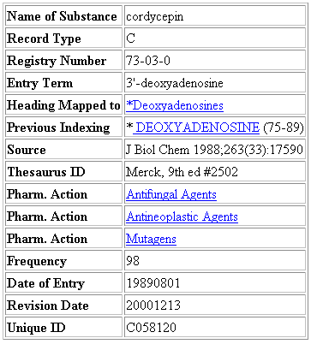

Record Type = C for Supplemental Concepts
Registry Number = Unique number assigned to chemicals by the Chemical Abstracting Service or a code for enzymes assigned by the Commission on Biological Nomenclature
Heading mapped to = Descriptor used for indexing this substance in MEDLINE
Previous Indexing = MeSH terms used before the current Descriptor was available; also, terms removed from the Heading Mapped to field over time
Source = Citations to articles in which the chemical has been identified
Thesaurus ID = Authoritative reference where the chemical is listed
Pharmacologic Action = Action of a drug or chemical as reported in the literature
Frequency = Number of times the chemical has been identified in MEDLINE journals
Date of Entry = Date record was added to the system
Other available fields in Supplemental Concept Records:

CAS Type 1 Name = Systematic name of a chemical which defines its structure
Related Number = Registry numbers for salts and/or stereoisomers
Indexing Information = Other MeSH terms that an indexer should consider using
Note = Additional information

  - Publication Types
    - These are terms that describe publication types.
- All available publication types may be viewed by using the “Preview/Index” function of PubMed. Access the Preview/Index page, select “Publication Type” from the All Fields drop down menu and then click on Index:

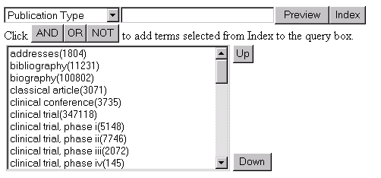

- Additionally, the available Publication Types are now in Limits:

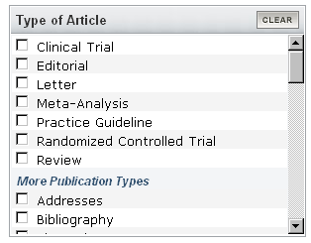

A listing of all the available publication types and their scope notes may also be found at http://www.nlm.nih.gov/mesh/pubtypes2008.html. A listing is also found at the end of this section.
- Additional components of the MeSH vocabulary: In addition to descriptors (MeSH main headings), subheadings (qualifiers), supplementary concepts, and publication types, two additional vocabulary groups in MeSH are:

  - CAS Registry Number/EC Number
    - This is a unique 5 – 9 digit number in hyphenated format representing the Chemical Abstracts number. The Chemical Abstracts registry number is sometimes referred to as the RN number.

Examples:
439-14-5 is the CAS registry number for diazepam (Valium)
54910-89-3 is the registry number for fluoxetine (Prozac)

- The EC numbers are classification numbers for enzymes. Each begins with “EC” and is followed by four numbers separated by periods.

Examples:
EC 1.1.3.4 is the EC number for glucose oxidase.
EC 4.1.99.1 is the EC number for tryptophanase.

- An RN or EC number may be used to search PubMed.

- The registry numbers for substances may be seen in the “Medline” type display for a citation in PubMed (the RN field) or in the MeSH section’s browser in appropriate records.

  - Age Groups

- These are MeSH headings that indicate the age of human subjects discussed in an article.
- Age Groups are found in the “Persons” tree of the MeSH hierarchy

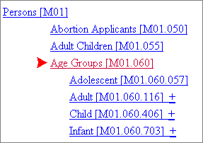

MeSH Tree Structure

- Descriptors are arranged in a hierarchy known as the Tree Structure.

- There are 16 main branches to the MeSH Tree. These are the broadest categorizations in MeSH and narrower, more specific terms reside under each of these (the branches) (http://www.nlm.nih.gov/mesh/trees2008.html).
The trees are:

A. Anatomy
B. Organisms
C. Diseases
D. Chemicals and Drugs
E. Analytical, Diagnostic and Therapeutic Techniques and Equipment
F. Psychiatry and Psychology
G. Biological Sciences
H. Physical Sciences
I. Anthropology, Education, Sociology and Social Phenomena
J. Technology and Food and Beverages
K. Humanities
L. Information Science
M. Named Groups
N. Health Care
V. Publication Characteristics
Z. Geographic Locations

- Descriptors can “live” on more than one branch of the MeSH Tree.
Ear is part of the Body Regions tree (A01)
Ear is also part of the Sense Organs tree (A09)
- See http://www.nlm.nih.gov/mesh/MBrowser.html for an interactive link to the Tree Structure. Click on the “Navigate from Tree Top” button. This will allow exploration of any tree from top (broadest concepts) to bottom (most specific concepts).
- MeSH descriptors are assigned numbers. Note, however, that MeSH numbers are not used for searching. They simply indicate the relationships between concepts. There is a direct relationship between the length of the number and the specificity of the term. For example:

Asthma --------------- [C08.127.108] is more specific than
Bronchial Diseases -- [C08.127]

New England -------- [Z01.107.567.875.550] is more specific than
United States --------- [Z01.107.567.875]

Exploding

- The hierarchical arrangement of MeSH allows for exploding. Exploding refers to the automatic inclusion of the more specific MeSH terms in a search when a broad MeSH term is chosen for a search.

For a simple example, the MeSH term SMOKING looks like this in the tree structure:

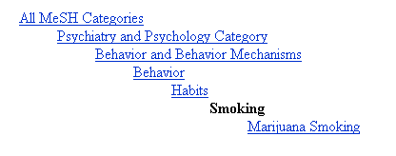

A PubMed search using the MeSH term SMOKING will automatically explode – meaning that it will also include the more specific MeSH term MARIJUANA SMOKING in the search.

The MeSH tree for other terms can be quite a bit longer and more complex meaning that exploding those terms includes many narrower terms. See the MeSH term WOUNDS AND INJURIES for a good example.

- The automatic exploding of MeSH descriptors can be turned off using the “Do not explode” option in the Entrez MeSH database’s full display:
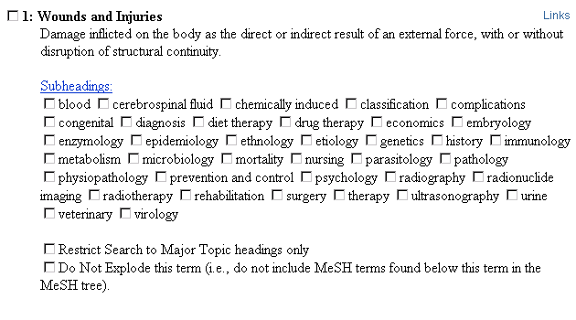

- Or, the automatic exploding of MeSH descriptors may be turned off by using the [MESH:NOEXP] tag in the search:

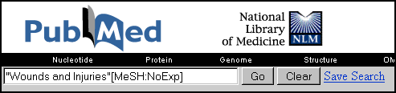

- Qualifiers (subheadings) are also subject to automatic exploding. A list of the families of qualifiers appears at the end of this section. To turn off the automatic exploding feature, use the [sh:noexp] tag for floating subheadings and the [mh:noexp] tag for MeSH heading/subheading combinations.

Using Qualifiers (subheadings)

- When articles are indexed for Medline, the MeSH terms are often (not always) accompanied by a subheading because, as noted above, indexers index to the most specific term available.

- Subheadings are attached to MeSH headings in the following manner: MeSH/Subheading (or MH/sh). The subheadings may be spelled out in full or the official two letter abbreviation may be used.

For example:

What are the adverse side effects of tamoxifen?
Use: Tamoxifen/adverse effects
Tamoxifen/ae

What is the cause of hypercholesterolemia?
Use: Hypercholesterolemia/etiology
Hypercholesterolemia/et

- Only one subheading may be attached to a MeSH heading at a time. DO NOT use MH/sh/sh. To include several subheadings in a search:

    - PubMed: In the PubMed search box, “OR” together the MH/sh combinations in the PubMed search box. For example:
“asthma/mortality” OR “asthma/etiology OR asthma/therapy MeSH

    - Database: In the PubMed MeSH Database, select the desired subheadings from the full display screen by checking the appropriate boxes. Then, choose an option from the “Send to” drop-down box to add the headings/subheadings to the search box.

- Floating subheadings in a search:

  - Floating subheadings refers to the practice of using a subheading in a search without attaching it to a particular MeSH descriptor. This involves combining a MeSH heading with a subheading using the Boolean AND.

  - The decision to “free-float” a subheading is typically done when the subheading of interest is one that cannot be applied to the MeSH descriptor being searched:

Childrearing [mh] AND complications [sh]

  - Using floating subheadings may result in a lot of noise (false drops or false hits) in the search results.

- Note: These searches are NOT identical:
urticaria/et
urticaria[mh] AND etiology[sh]
urticaria AND etiology
urticaria/et[mh:noexp]

  - The search “urticaria/et” will result in citations indexed with “urticaria/etiology”. However, remember that both MeSH and the subheadings automatically explode to include narrower terms from the hierarchy, resulting in citations focused on solely on, for example, “angioneurotic edema/genetics”.

  - The search “urticaria[mh] AND etiology[sh]” will include the above citations, but it will also pull up “urticaria/chemically induced”, “pneumonia/etiology” and any other citation in which a MeSH heading is combined with the subheading – or their explosions.

  - In “urticaria AND etiology”, in addition to the MeSH headings of “urticaria”, “causality[mh]” (the MeSH term for etiology) is also searched. This search provides the greatest number of results and includes the above.

  - The most specific search is “urticaria/et[mh:noexp]” as it will retrieve only citations that have “urticaria/etiology” in the indexing. However, etiology will still explode.

- When using MeSH for searching, remember that the most specific MH or MH/sh combination is used to index articles. Searchers need to do the same in order to get the most relevant results.
SUBHEADINGS

Abnormalities | AB | Isolation & Purification | IP
Administration & Dosage | AD | Legislation & Jurisprudence | LJ
Adverse Effects | AE | Manpower | MA
Agonists | AG | Metabolism | ME
Analogs & Derivatives | AA | Methods | MY
Analysis | AN | Microbiology | MI
Anatomy & Histology | AH | Mortality | MO
Antagonists & Inhibitors | AI | Nursing | NU
Biosynthesis | BI | Organization & Administration | OG
Blood | BL | Parasitology | PS
Blood Supply | BS | Pathogenicity | PY
Cerebrospinal Fluid | CF | Pathology | PA
Chemical Synthesis | CS | Pharmacokinetics | PK
Chemically Induced | CI | Pharmacology | PD
Chemistry | CH | Physiology | PH
Classification | CL | Physiopathology | PP
Complications | CO | Poisoning | PO
Congenital | CN | Prevention & Control | PC
Contraindications | CT | Psychology | PX
Cytology | CY | Radiation Effects | RE
Deficiency | DF | Radiography | RA
Diagnosis | DI | Radionuclide Imaging | RI
Diagnostic Use | DU | Radiotherapy | RT
Diet Therapy | DH | Rehabilitation | RH
Drug Effects | DE | Secondary | SC
Drug Therapy | DT | Secretion | SE
Economics | EC | Standards | ST
Education | ED | Statistics & Numerical Data | SN
Embryology | EM | Supply & Distribution | SD
Enzymology | EN | Surgery | SU
Epidemiology | EP | Therapeutic Use | TU
Ethics | ES | Therapy | TH
Ethnology | EH | Toxicity | TO
Etiology | ET | Transmission | TM
Genetics | GE | Transplantation | TR
Growth & Development | GD | Trends | TD
History | HI | Ultrasonography | US
Immunology | IM | Ultrastructure | UL
Injuries | IN | Urine | UR
Innervation | IR | Utilization | UT
Instrumentation | IS | Veterinary | VE
 |  | Virology | VI

http://www.ncbi.nlm.nih.gov/books/bv.fcgi?rid=helppubmed.table.pubmedhelp.T41

Families of Subheading Explosions

adverse effects | etiology | physiology
poisoning | chemically induced | genetics
toxicity | complications | growth & development
 | secondary | immunology
analysis | congenital | metabolism
blood | embryology | biosynthesis
cerebrospinal fluid | genetics | blood
isolation & purification | immunology | cerebrospinal fluid
urine | microbiology | deficiency
 | virology | enzymology
anatomy & histology | parasitology | pharmacokinetics
blood supply | transmission | urine
cytology |  | physiopathology
pathology | metabolism | secretion
ultrastructure | biosynthesis
embryology | blood | statistics & numer data
abnormalities | cerebrospinal fluid | epidemiology
innervation | deficiency | ethnology
 | enzymology | mortality
chemistry | pharmacokinetics | supply & distribution
agonists | urine | utilization
analogs & derivatives
antagonists & inhibitors | microbiology | surgery
chemical synthesis | virology | transplantation
complications | organization & admin | therapeutic use
secondary | economics | administration & dosage
 | legislation & jurisprudence | adverse effects
cytology | manpower | contraindications
pathology | standards | poisoning
ultrastructure | supply & distribution
 | trends | therapy
diagnosis | utilization | diet therapy
pathology |  | drug therapy
radiography | pharmacology | nursing
radionuclide imaging | administration & dosage | prevention & control
ultrasonography | adverse effects | radiotherapy
 | poisoning | rehabilitation
embryology | toxicity | surgery
abnormalities | agonists | transplantation
 | antagonists & inhibitors
epidemiology | contraindications
ethnology | diagnostic use
mortality | pharmacokinetics

Available at: http://www.nlm.nih.gov/mesh/subhierarchy2008.html with links to definitions.
PubMed Publication Types

Use bolded publication types for evidence-based medicine searches.

Addresses | Interview
Lectures | Journal Article
Bibliography | Review
Biography | Lectures
Case Report | Legal Cases
Classical Article | Legislation
Clinical Conference | Letter
Clinical Trial | Meta-Analysis
Clinical Trial, phase I | Multicenter Study
Clinical Trial, phase II | News
Clinical Trial, phase III | Newspaper Article
Clinical Trial, phase IV | Overall
Controlled Clinical Trial | Patient Education Handout
Multicenter Study | Periodical Index
Randomized Controlled Trial | Practice Guideline
Comment | Published Erratum
Congresses | Randomized Controlled Trial
Overall | Retraction of Publication
Comparative Study | Retraction of Publication
Consensus Development Conference | Review
Consensus Development Conference, NIH | Consensus Development Conference
Controlled Clinical Trial | Consensus Development Conference, NIH
Corrected and Republished Article | Review, Multicase
Dictionary | Review of Reported Cases
Directory | Review, Tutorial
Duplicate Publication | Scientific Integrity Review
Editorial | Support of Research
English Abstract | Research Support, Non-U.S. Gov’t
Evaluation Studies | Research Support, U.S. Gov’t, Non-P.H.S.
Festschrift | Research Support, U.S. Gov’t, P.H.S.
Government Publications | Research Support, N.I.H., Extramural
Guideline | Research Support, N.I.H., Intramural
Practice Guideline | Technical Report
Historical Article | Twin Study
Biography | Validation Study
Interview
Classical Article
Festschrift

Available by searching the PubMed Help manual for Publication Types; or go directly to:
http://www.ncbi.nlm.nih.gov/books/bv.fcgi?rid=helppubmed.table.pubmedhelp.T42

For definitions of terms, visit: http://www.nlm.nih.gov/mesh/pubtypes2008.html
For the Publication Characteristics, visit the MeSH Browser at: http://www.nlm.nih.gov/mesh/2008/MeSHtree.V.html
or search in the MeSH Database for each term

MeSH Browsers & Databases

- There are two MeSH browsers available: the Entrez MeSH Database (PubMed) and the MeSH section’s online browser.

  - The Entrez MeSH Database may be accessed via a link on the left hand side (blue frame) of the PubMed page (“MeSH Database”).

  - The MeSH section’s browser is located at: http://www.nlm.nih.gov/mesh/MBrowser.html
or follow the links from the MeSH Database above, click first on “MeSH” and then “online searching” under MeSH Browser.

- Both of these will identify MeSH terms and show the section of the MeSH tree pertinent to that concept. Beyond that, they display much of the same information in different ways and they provide different functionality. For example, look at the browser information for the MeSH term COMMON COLD:

From the Entrez MeSH Database’s full display:

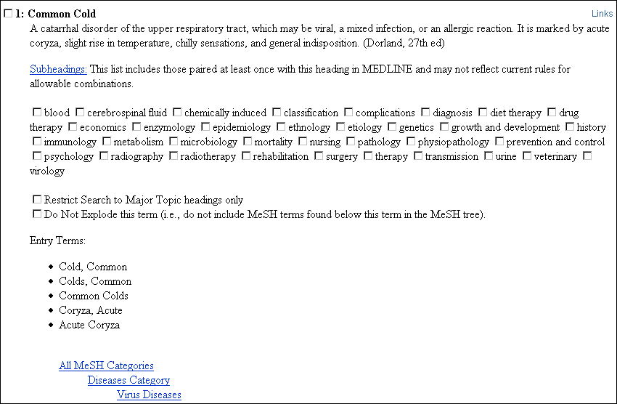

- In the Entrez MeSH Database, a definition of the descriptor is provided.

- Subheadings are presented here with check boxes. Users may select none, one, or more subheadings to add to their search. NOTE: In the Entrez MeSH database the subheadings listed are those that have been paired at least once with a descriptor and may not reflect current rules for heading/subheading use.
- Two other search related options are available from this page:
  - Restrict Search to Major Topic headings only
  - Do Not Explode this term
- A PubMed search may be built directly from this Database using the “Send to” options at the top of the page [not pictured here].

From the MeSH section’s browser:

MeSH Heading | Common Cold
Tree Number | C02.782.687.207
Tree Number | C08.730.162
Annotation | often caused by a picornavirus
Scope Note | A catarrhal disorder of the upper respiratory tract, which may be viral, a mixed infection, or an allergic reaction. It is marked by acute coryza, slight rise in temperature, chilly sensations, and general indisposition. (Dorland, 27th ed)
Entry Term | Cold, Common
Entry Term | Coryza, Acute
Allowable Qualifiers | BL CF CI CL CN CO DH DI DT EC EH EM EN EP ET GE HI IM ME MI MO NU PA PC PP PS PX RA RH RI RT SU TH TM UR US VE VI
Unique ID | D003139

- The Entry terms are synonyms or concepts included by this MeSH heading. If an entry term is typed into the search box in PubMed it will map to the designated descriptor. In this example, “Coryza, Acute” will map directly to the Mesh descriptor COMMON COLD.

- The annotation presents additional information on the concept that may be of use to indexers and/or searchers.

- The allowable qualifiers are the subheadings (qualifiers) that may be used with this term. In the MeSH section browser, these two letter abbreviations for each subheading are hyperlinks that, if followed, will link directly to the record for the subheading.

A Comparison of the two Browsers:

Entrez MeSH Database |  | NLM MeSH Browser
Definition |  | Definition (scope note)
No annotation | ↔ | Annotation: info for indexers (and searchers)
Entry terms |  | Entry terms
History: year concept added to MeSH |  | History: year concept added to MeSH
Previous indexing available |  | Previous indexing available
“See also” concepts available & hyperlinked |  | “See also” concepts available & hyperlinked
RN numbers searchable | ↔ | RN numbers searchable
Subheading records available. These must be searched as separate terms.  Note: subheadings appear here without indication of headings to which they may be applied. |  | Subheading records available. Within a Descriptor record, the available subheadings are hyperlinked. Note: This database shows the subheadings that are currently allowed for use with a given MeSH heading.
Pharmacological action data (2003) |  | Pharmacological action data available
Can build a PubMed search here | ↔ | Can NOT build a PubMed search here
Provides some help for misspelled words | ↔ | Words must be spelled correctly in order to be searched here
Suggests other terms of possible interest |  | Provides the option of searching for the exact term, all fragments, or any fragment
No permuted index available | ↔ | Permuted index available
Supplementary concept records available as of 10-14-2004 |  | Supplementary concept records available

NOTE: The NLM Gateway also has a database of terms called the Term Finder. It is available from a link on the Gateway page: http://gateway.nlm.nih.gov/

- The Term Finder provides some of the same functionality as seen in the two browsers discussed above as well as additional functionality (particularly when it comes to non-MeSH terms).

- In addition to the MeSH terminology, the Gateway also pulls from NLM's Unified Medical Language System (UMLS) Metathesaurus (which contains information about biomedical concepts and terms from many sources).

OLDMEDLINE Citations

Over 1.7 million OldMedline citations have been added to PubMed. These citations were originally printed in the Cumulated Index Medicus (CIM) and the Current List of Medical Literature (CLML) published from 1953 through 1965. In 2005, NLM began to map the OLDMEDLINE Other Terms to current MeSH vocabulary and those citations which had all of their original subject headings mapped to current MeSH became MEDLINE citations. (See http://www.nlm.nih.gov/databases/databases_oldmedline.html)

The data in these older records differ from that in the current PubMed records in several important ways:
- Abstracts: Less than 0.5% of the current and former OLDMEDLINE citations have abstracts.
- Publication Type: Only “Journal Article” was used.
- Language: Some citations will indicate “und” because the actual foreign language was not specified and is, therefore, undetermined.
- Article titles: Some are all in caps; over 38,000 citations show “Not Available” as the title because they lack English translations of the titles.
- Other Term: This field contains the original MeSH terms assigned at the time the records were first established.
- Journal Title Abbreviations: Journal title abbreviations may have been changed from the abbreviation found on the original OLDMEDLINE citation; however, using an old abbreviation will retrieve across all years. NLM's catalog, LOCATORplus, will have old title abbreviation data on serial records for these journals. As always, full title names can be used for searching in PubMed.
- Entrez Date: The Entrez date for these citations is created using the date of publication on the citation. This is necessary to prevent older citations from displaying near the top of retrieval as the default display order in PubMed is reverse chronological order of the Entrez date (i.e., last in - first out).

Searching considerations:
- These older records may not have fields frequently found on MEDLINE records, including: Abstract [AB], Affiliation [AD], EC/RN Number and Name of Substances [RN], Grant Numbers [GR] and MeSH [MH].

- The [PubMed - OLDMEDLINE] tag identifies those citations for which the Other Term mapped in incomplete – under 420,000 citations. These citations may be searched by using the oldmedline [sb] directly in a search.

- Use jsubsetom as a journal subset to access all of the older citations, both those with the OLDMEDLINE tag and the remaining 1.34 million citations with the [PubMed - indexed for MEDLINE] tag.

N O T E S

Automatic term mapping

- Automatic Term Mapping is a process the PubMed search engine uses every time a word or words are typed into the search box and a search is initiated.

- Note: Automatic Term Mapping does not apply when:

- Truncation is used in the search
- Quotation marks are used in the search string
- Tags are used to indicate the field to be searched (eg., [TA] or [journal] or [MESH:NOEXP])

- The Automatic Term Mapping process consists of three steps in which the PubMed search engine compares what is in the search box to three separate tables. Those steps, in order, are:

  - MeSH/publication types
  - Journal Titles
  - Author

The DETAILS box in PubMed will show you EXACTLY how Automatic Term Mapping was applied to your search.

 | Practice Safe Searching: Always check the details box.

- Step one: MeSH / Publication Types / Substance Names

- Whenever a word or words are typed into the search box, PubMed’s search engine looks at the words as a group and compares them to a table of MeSH terms (descriptors and qualifiers), publication types, and substance names.

- If it finds a match, the appropriate MeSH/pub type/substance name is applied, a text word search (the term in the search box) is added to the search using OR, and the search is executed. No further steps are taken. Effective Nov. 22, 2004, an additional piece may be added to the search (“xxxxxx”[TIAB] NOT MEDLINE[sb]”) in order to enhance retrieval of non-MEDLINE citations.

- If it does not find a match with a MeSH term and/or publication type and/or substance name, it moves on to step two.
Example: Type “nosebleed” into the PubMed search box. The Details box will show how Automatic Term Mapping translated the search:

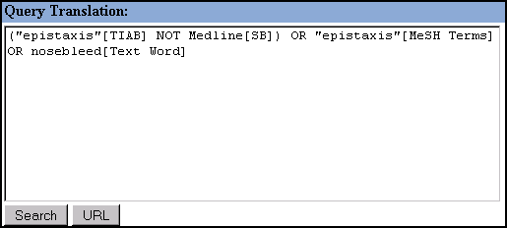

Note: If the search term maps both to a MeSH term and a publication type, the mapping will include both. See the Details box for a search on “practice guidelines”:

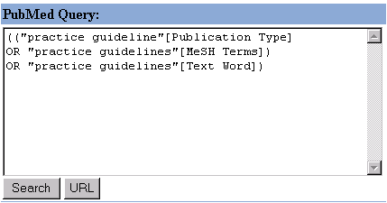

- Step two: Journal titles

- If there has been no match with a MeSH/publication type/substance name (step one), then PubMed’s search engine compares the words in the search box to a table of journal titles.

- If it finds a match, the appropriate journal title is applied and the search is executed. No further steps are taken.

- If it does not find a match with a journal title, it moves on to step three.
Example: Type “tuber lung dis” as the search and PubMed will automatically map this to "Tuber Lung Dis"[Journal]. All the citations will be from the journal Tubercle and Lung Disease. This happens because “tuber lung dis” is not a MeSH term or publication type (so no match in step one) but it is the official Medline abbreviation for that journal (match in step two).

Example: To find all the citations from the journal Brain, type “brain” into the search box. However, the Details tab reveals: ("brain"[MeSH Terms] OR brain[Text Word]). Why? “Brain” maps to a MeSH term. PubMed stops the Automatic Term Mapping process because it found a MeSH term in step one and runs the search. Turn off the Automatic Term Mapping and have PubMed retrieve citations from the journal by typing “brain[journal]” into the search box.

- Step three: author names

- If there has been no match with a MeSH term or publication type and no match with a journal title, then PubMed’s search engine compares what is written in the search box to a table of author names. Both the full author translation table (started in 2002) and the author index table are searched.

- If there is a match, the appropriate author name is applied and the search is executed.

Example: Type “martini r” into the search box and the Details box will show the search has been translated to “martini r[Author]”.

Example: Suppose you are looking for articles written by Treat. If you type “treat” into the search box and then check the Details tab, you find the search has been translated into: ("therapy"[MeSH Subheading] OR treat[Text Word]). Why? Treat maps to the MeSH qualifier “therapy” and, once that mapping has occurred, PubMed thinks the search has been successfully mapped and takes no further step. To force PubMed to find the author name Treat, type “treat[author]” into the search box to turn off the Automatic Term Mapping.

- If there is no match, one of two things may happen:

      - If there is only one word in the search box and there have been no matches with MeSH/publication type or journal title or author name, then a general All Fields search is run.

      - If there are several words in the search box, PubMed will ignore the word that is furthest to the right and apply Automatic Term Mapping to the remaining words. This lopping will continue, always from the right hand side, until there is either a suitable match made or there are no matches to be made (at which time an All Fields search will be done).
- What if Automatic Term Mapping isn’t doing what I want it to do?

There are numerous ways to remedy this. Here are three:

- Direct PubMed to the field you want searched by using a field tag.

- Edit the search directly in the Details box, inserting the more appropriate MeSH terms or redirecting the search to a particular field.

- Use quotation marks to search for a particular phrase and turn off Automatic Term Mapping.

- What are the advantages of Automatic Term Mapping?

  - Searchers do not have to look first for the MeSH term and then run the search. It’s done automatically.

  - Even novice searchers will find relevant information – and be taking advantage of MeSH searching without even knowing it.

  - Searchers do not have to remember to append the text word search onto their search string in an effort to get at the citations added most recently to the database. This is done automatically.

Direct MeSH Searching

It is possible to search using MeSH terminology without using either the Entrez MeSH Database or Automatic Term Mapping. This can be accomplished in a number of ways:

- Construct a search using the Preview/Index function. Select the appropriate field from the “All Fields” drop-down menu and use the Index function to help select terms.

- Construct the search using the Limits function of PubMed. Select the appropriate field from the “All Fields” drop-down menu on the Limits screen.

- Construct the search using appropriate field tags in either the Search box or the Details box. Appropriate field tags may include the following:

[mh] → MeSH heading
[majr] → MeSH Major heading
[mh:noexp] → MeSH heading, do not explode
[majr:noexp] → Mesh Major heading, do not explode

- Add terms to a search by using the hyperlinked MeSH terms from the Citation display format for an indexed citation.

Searching With Field Tags

- Search fields can be specified using PubMed’s search field tags. A list of the available field names, abbreviation, and brief field descriptions may be found in the PubMed Help under Search Field Descriptions and Tags. Abbreviations are listed below with a brief description.

- Each search term should be followed with the appropriate search field tag, indicating which field will be searched. The search field tag must follow the term. You cannot prequalify a term. The term must be post qualified.

Correct entry: aromatherapy [mh]
Incorrect entry: [mh] aromatherapy

- Search field tags must be enclosed in square brackets [ ]

- Case and spacing do not matter: iris[mh] = Iris [mh] = IRIS [MH]

Search Rules and Syntax

- The Boolean operators AND, OR, NOT should be entered in uppercase letters. In most cases, lower case does not cause problem; saved searches are one exception.

- Boolean connectors are processed left to right

- Nesting of search terms is possible. To change the order in which terms are processed, enclose the concept(s) in parentheses. The terms inside the set of parentheses will be processed as a unit and then incorporated into the overall strategy. This is called nesting.

Example: shoulder joint [mh] AND (baseball[mh] OR hockey [mh]) AND arthroscopy [mh]

Search Field Abbreviations

AUTHOR | SUBJECT | JOURNAL | OTHER
[AU] Author Name | [MH] MeSH Terms | [TA] Journal Title | [SI] Secondary Source
[AD] Affiliation | [MAJR] Mesh Major Topic | [EDAT] Entrez Date | [UID] Unique Identifier
[1AU] First named author | [SH] MeSH Subheading | [DP] Publication Date | [FI] Filter
[FAU] Full author name | [PT] Publication Type | [PPDAT} Print Publication Date | [SB] Subset
[LASTAU] Last named author | [RN] EC/Registry Number | [EPDAT] Electronic Publication Date | [LA] Language
[CN] Corporate author | [NM] Substance Name | [VI] Volume | [OT] Other term
 | [PA] Pharmacologic action MeSH term | [IP] Issue | [TI] Title words
 | [FPS] Full Personal Name as Subject | [PG] Pagination | [TIAB] Words in title or abstract
 | [PS] Personal Name as Subject |  | [TW] Text Words

http://www.ncbi.nlm.nih.gov/books/bv.fcgi?rid=helppubmed.section.pubmedhelp.Search_Field_Descrip

Author Searching [AU]

- Use [au] tag. Examples: o’brien j [au]; pizza[au]

- If the first initial is included, PubMed automatically truncates the author’s name to account for varying initials. To turn off automatic truncation of an author’s name:
(1) surround the author’s name with double quotes and use the [au] search tag; or,
(2) place an @ sign after the author’s first initial

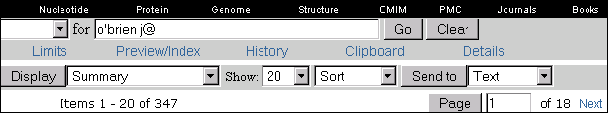

NOTE: For records created 1966-1983, the number of authors allowed per citation was not limited. Between 1984-1995, only 10 authors were allowed, with “et al” designating the existence of additional authors. From 1996-1999, the number of authors allowed was increased to 25 (the first 24 named authors, the last named author, followed by “et al”). And, in 2000, the restriction on the number of authors was removed.

Full Author Names [FAU] are included in MEDLINE records in the FAU field as of 2002. The field is searchable as of May 2005.

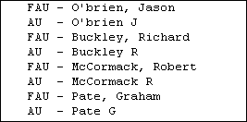 | Author names may be entered in regular or inverted order: Richard Buckley or Buckley, Richard. The comma between last name and first name is not required but may be needed in some cases to distinguish a surname from a given name. Example: Ryan, James with the comma to distinguish James Ryan from Ryan James.

NOTE: Full author names are entered into the MEDLINE record when they appear in the author position of an article, usually on the title page of the article. If only the last name and initials appear in the author position, then only the last name and initials will be entered, even if a form of the fuller name appears elsewhere in the article or in the Table of Contents for the journal.

First Named Author [1AU] or Last Named Author [LASTAU]: It is now possible to limit author searching to the first named personal author or the last named personal author on a citation. These options are also available in the Single Citation Matcher and as a Sort option.

Note: pizza[au] and pizza[1au] and pizza [lastau] are different searches.

Corporate Author [CN]

- Identifies the corporate authorship of an article.

- Corporate names display exactly as they appear in the journal.

- This field was added to records in 2001. Prior to 2001, corporate author information was contained only at the end of the title field.

- Citations indexed pre-2000 and some citations indexed in 2000-2001 retain corporate authors at the end of the title field. For comprehensive searches, consider including terms and/or words searched in the title field [ti].

- Corporate author names are not standardized, edited, or translated into English by NLM. [The exception to this is Arabic, Chinese, Hebrew, and Japanese – NLM will input a translation of the corporate author into the CN field.]

Personal Name as Subject [PS]

- Use the [ps] tag to search for citations to articles about a named individual. The name is searched in the same format as for authors.

- This field is not available in either Limits or in the Preview/Index function in PubMed. The only way to search this is to use the [PS] tag.

- FPS: The Full Personal name as Subject field displays in the MEDLINE format in PubMed and contains the full name of the subject of the article for citations with a date of publication beginning in 2002. The FPS field is not currently searchable, however.

Example: Use bush gw [ps] for articles about George W Bush

- Many of the older citations reference articles about historical figures. (See OLDMEDLINE Citations above.) To search for an atypical name, use:

Example: louis xiv [ps]
st paul [ps]

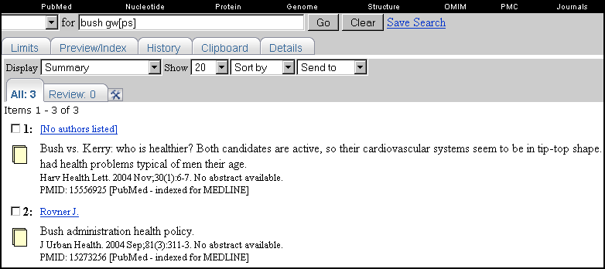

Affiliation [AD]

- Traditionally, this includes the institutional affiliation and address (including email address) of the first named author of the article as it appears in the journal.

- This field can be used to search for work done at specific institutions, but it will only retrieve citations that have the institutional name appearing in the address.

Example: cleveland [ad] AND clinic [ad]
Example: Cleveland clinic [ad]

Grant Number [GR]

- Grant and contract numbers are also searchable using the [gr] search field tag.

Example: LM05545 [gr]

Grant and contract numbers display in the GR field of the MEDLINE format and in the Citation Format. In the Citation Format, these may appear as hyperlinks.

- This field was introduced in 1981 and is comprised of three parts:

- Number contains the research grant or contract number (or both) that designates financial support by any agency of the United States Public Health Service or any institute of the National Institutes of Health. The data are recorded exactly as they appear in the published article; there is no attempt to standardize the numbers.
- Acronym contains the 2-letter grant acronym.
- Agency contains the institute acronym or mnemonic.

- NOTE: As of June 2, 2005, Wellcome Trust is now added if an author acknowledges that the research was supported financially by this organization. The organization name is typically cited without a specific grant number.

Example: “Wellcome Trust”[gr]

 | The three pieces of the grant number (LM05545 - number, LM - acronym, and NLM - institute mnemonic) are each individually searchable using the [gr] tag.
 | More precise retrieval results from searching on the institute acronym (e.g., LM for NLM sponsored grants), rather than the institute mnemonic (e.g., NLM) because mnemonics may also occur in the street or email portion of addresses.
 | In cases where the grant acronym is also a state postal abbreviation (e.g., CA), search both the acronym and the mnemonic (e.g., ca [gr] and nci [gr]).

Registry Number [RN]

- 83-86-3 (Phytic Acid)

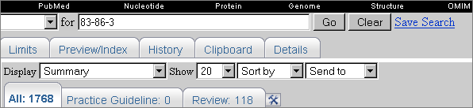

Substance Name [NM]
- Searching the substance name allows for more specific searching of drug & substance names.

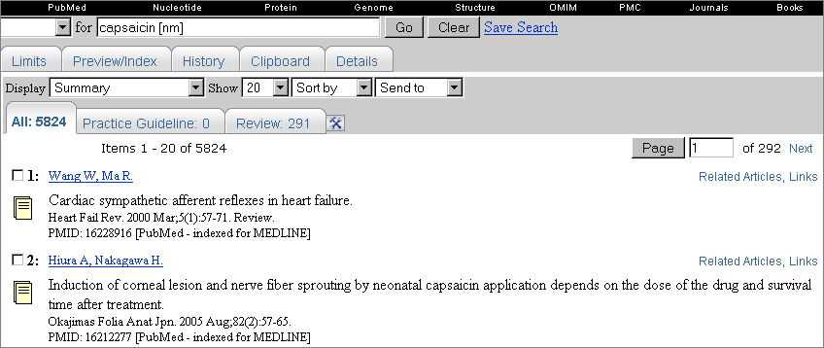

Text Words [TW]

- Terms or numbers that are searched with the Text Words [tw] field tag will be searched in the following fields:

  - Title
  - Abstract
  - MeSH headings and Subheading
  - Other Term [OT] field of OLDMEDLINE citations
  - Chemical Names of Substances
  - Secondary Source Identifier
  - Personal Name as Subject

Title Word Searching [TI] or Words in Title or Abstract [TIAB]

- Enter significant terms (numbers, too) from the title of an article.
- Each word must be followed by the [TI] search field tag.
- Words should be combined with the AND operator.

Example: I’m looking for an article. The title is Memory improvement following cardiac transplantation.

Search: memory [ti] AND improvement [ti] AND cardiac [ti] AND transplantation [ti]

Result:

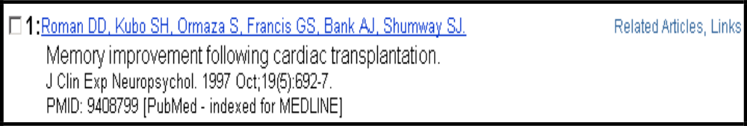
Consider using the Single Citation Matcher available from the sidebar. When using Single Citation Matcher, you do not have to tag each title word. Or, choose Title from Limits (under Tag Terms), which also eliminates the need to qualify each word

Limiting to citations with abstracts

- Use the value: hasabstract

Do not use a field tag; just use the search value.

Example: baseball AND hasabstract

The “only items with abstracts” selection in Limits makes restricting to only items with abstracts easy.

Publication Type [PT]

- Describes the type of material the citation represents
- Examples: Twin Study, News, Review, Clinical Trial, Lectures, Letter

- Beginning in 2008, these terms map directly to the publication type and the [PT] is assumed. For example, a search for clinical trial results in:

"clinical trial"[PT] OR "clinical trials as topic"[MH] OR "clinical trials"[TW] where in the first, clinical trial is the publication type, in the second it is the topic of the article and in the third PubMed performs a text word search on the word.

- Optional: Use the [pt] tag to force the search and eliminate searching for the defaulted terms noted above

Example: vascular diseases [majr] AND twin study [pt]

See http://www.nlm.nih.gov/mesh/pubtypes2008.html from the NLM MeSH section for a listing of all available publication types for 2008. Includes scope notes.

PubMed’s Help also includes a listing of all available Publication Types.
http://www.ncbi.nlm.nih.gov/books/bv.fcgi?rid=helppubmed.table.pubmedhelp.T42

All available publication types may be viewed by using the Preview/Index function of PubMed. Access the Preview/Index page, select “Publication Type” from the All Fields drop down menu and then click on Index.

Other Term [OT]

- Pertains to OLDMEDLINE citations.
- The OT field contains the original MeSH Headings assigned at the time the records were first established prior to 1966. These headings have not been updated and may not match current MeSH headings and subheadings.
- For additional information on the OT field, see the OLDMEDLINE section of this manual or the NLM Technical Bulletin article at http://www.nlm.nih.gov/pubs/techbull/so03/so03_oldmedline.html
- The OT field is also searchable with the [TW] tag.

Language [LA]

- The language in which the article is written.

- First three letters of the language may be used as an abbreviation when searching.
(There are a few exceptions. Example: JPN for Japanese)
- Language values may also be spelled out.
Examples: common cold [mh] AND chi [la]
common cold [mh] AND chinese [la]
common cold [mh] AND por [la]
common cold [mh] AND portuguese [la]

Languages are available from the pull-down menu in Limits. The full list of languages can also be viewed and searched using the Preview/Index feature

Journal Name [TA]

- Search for journals using the full journal name, or the MEDLINE abbreviation, or the ISSN.

Examples: journal of biological chemistry [ta]
j biol chem [ta]
0021-9258 [ta]

When searching journal titles, consider using the Journal Database or the Single Citation Matcher. There is less opportunity for error with these methods.

Entrez Date [EDAT]

- The Entrez Date field contains the date that the record was initially added to PubMed. However, in citations of publications before September 1997, the Entrez Date is set to the Publication Date.
.
- Search this in the format yyyy/mm/dd [edat]

Example: 1999/07/10 [edat]

- Month and day are optional:

Example: 1999 [edat]
Example: 1999/07 [edat]

The Entrez Date will remain unchanged and is not updated to reflect the date a publisher-supplied record is elevated to in process, or when an in process record is elevated to MEDLINE status.

For citations prior to 1997, the Entrez date is created using the citation’s date of publication to prevent older citations from displaying near the top of retrieval.

Publication Date [DP], [EPDAT], and [PPDAT]

- The date that the article was published in the format of YYYY/MM/DD.
- Use the [DP] search tag for the publication date as it appears in the journal. To search for electronic dates only use the search tag [EPDAT], for print dates only tag with [PPDAT].
- Month and day are optional.

Examples:
1984/10/06 [dp]
1984/10 [epdat]
1984 [ppdat]

If an article is published electronically and in print on different dates both dates are searchable and may be included on the citation prefaced with an Epub or Print label. The electronic date will not be searchable if it is later than the print date, except when range searching.

Date Ranging [EDAT] and [DP], [EPDAT], and [PPDAT]

- The colon (:) is used between ranging values.

- To search for Publication Date between 1993 and 1997, enter:

1993:1997 [dp]
- The proper date format is YYYY/MM/DD

EDAT = Entrez Date.
DP = Date of Publication – generally the date appearing on the journal, but when searching may also be the electronically published date
EPDAT = Electronic Publication Date – date citation was submitted to PubMed from the publisher.
PPDAT = Print Publication Date – date appearing on the journal.

Example 1:
Search for citations entered into PubMed from Jan 16, 1998 to Feb 13, 1998

1998/01/16:1998/02/13 [edat]

Example 2:
Search for citations published either electronically in or with a print date of January or February 1998

1998/01:1998/02 [dp]

Use the following format to search X days, months or years immediately preceding today’s date where X = numeric value (quotation marks required):
- “last X days”[dp]
- “last X months”[epdat]
- “last X year”[ppdat]

Volume [VI], Issue [IP], Pagination [PG]

Consider using the Single Citation Matcher available from the sidebar. When using Single Citation Matcher, you do not have to tag each volume, issue, or page.

Secondary Source Identifier [SI]

- Beginning with the summer of 2005, NLM includes the ClinicalTrials.gov identifier number in the SI field when that information appears in the original publication as recommended by the International Committee of Medical Journal Editors (ICMJE).

- SI field also identifies secondary source databanks and accession numbers of molecular sequences discussed in MEDLINE articles.

- Currently, there are six databases registering molecular sequence data:

GDB | Johns Hopkins University Genome Data Bank
GENBANK | GenBank (NIH)
OMIM | Online Mendelian Inheritance in Man
PDB | Protein Data Bank
PIR | Protein Identification Resource
SWISSPROT | Protein Sequence Database

- The field is composed of the source followed by a slash followed by an accession number and can be searched with one or both components.

Examples: GENBANK/AF306859
SWISSPROT/P13209
ClinicalTrials.gov/NCT00000419

Search: genbank[SI]
AF306859[SI]
genbank/AF001892 [si].

- Data in this field is sorted first by databank name and then by accession number.

- The SI field and the Entrez sequence database links are not linked. The PubMed links to these databases are created from the reference field of the GenBank or GenPept flatfile. These references include citations that discuss the specific sequence presented in these flatfiles.

Unique Identifier Searching [UID]

- To search using the PubMed Unique Identifier (PMID), type in the number with or without the search field tag [uid].

Example: 11073054

- You can search for several Unique Identifier numbers by entering each number in the query box separated by a space, PubMed will OR them together. Do not enter the OR connector.

Example: 7715939 11073054

Unique Identifiers  as entered in the  query box.  PubMed finds the 2 citations. | 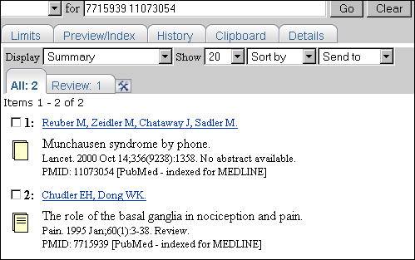

- To search for a Unique Identifier in combination with other terms you must use the search field tag [uid].

Example: smith [au] AND (10403340 [uid] OR vaccines [mh])

Subset [SB]

- Allows you to limit your search to various PubMed subsets.
- Use the [sb] tag for searching (with three exceptions)
- Available values include:

Level of processing  (Status) Subsets | Subject/Topic Subsets | Journal Subsets
- publisher [sb] | - aids [sb] | - medline pmc [sb]
- pubstatusaheadofprint | - bioethics [sb] | - free full text [sb]
- in process [sb] | - cancer [sb] | - hasabstract
- medline [sb] | - cam [sb] (Complementary Medicine) | - jsubsetname
- pubmednotmedline[sb] | - history [sb] | - loprovmedlib [sb]
- oldmedline[sb] | - space [sb]
- pubstatusnihms | - systematic [sb] (Systematic Reviews)
- all [sb] | - tox [sb] (Toxicology)
 | - veterinary[sb] (Veterinary Medicine/ Animal Health)
http://www.ncbi.nlm.nih.gov/books/bv.fcgi?rid=helppubmed.table.pubmedhelp.T39
http://www.ncbi.nlm.nih.gov/books/bv.fcgi?rid=helppubmed.section.pubmedhelp.Searching_PubMed#pubmedhelp.Topics

Limiting to published journal indexes

- The following values are available to limit to published (or previously published) journal indexes such as International Nursing Index.
- Do not use a field tag (e.g. [sb]); just use the search value → jsubsetcode
- Do not confuse JOURNAL subsets with SUBJECT subsets

Code | Journal/Citation Subset
AIM | Abridged Index Medicus is a list created 20 years ago of 120 core clinical English language journals that corresponds to "Core clinical journals" subset in Limits
D | Dentistry journals
E | Citations from bioethics journals or selected bioethics citations from other journals
H | Health administration journals, non-Index Medicus
IM | Index Medicus journals
K | Consumer health journals, non-Index Medicus
OM | OLDMEDLINE citations from Cumulated Index Medicus and Current List of Medical Literature
N | Nursing journals
Q | History of medicine journals and selected citations from other journals
QIS | Citations from non-Index Medicus journals in the field of history of medicine
S | Citations from space life sciences journals and selected space life sciences citations from other journals
T | Health technology assessment journals, non-Index Medicus
X | AIDS/HIV journals (selected citations from other journals 1980-2000)
http://www.ncbi.nlm.nih.gov/books/bv.fcgi?rid=helppubmed.table.pubmedhelp.T38

Filter [filter] or [sb]

- Technical tags used by LinkOut providers to qualify holdings.

- Use the following query to find all the LinkOut links in PubMed:

Loall [filter]

- You may also use Preview/Index to browse the index of LinkOut providers. Select Filter from the All Fields pull-down menu, enter “lo” in the adjacent search box, and then click “Index.” PubMed will display an alphabetic list of all the LinkOut entries.

- If a library has set up LinkOut for Libraries and linked their electronic journal collection and/or their DOCLINE SERIAL HOLDINGS to PubMed, it is possible to limit a search to just those holdings by using a filter. The filter begins with loprov and, following that are the letters assigned to that institution (their code).

Examples:

loprovmghlib will limit to the LinkOut holdings of the Massachusetts General Hospital Treadwell Library

loprovumasslib will limit to the LinkOut holdings of the U Mass Medical School library

To find a library’s code, click on LinkOut on the blue sidebar on the PubMed page. Then, click on “All Providers” to see a list.

- There are numerous other filters available in PubMed. These can be seen by using the Preview/Index function. Select “Filter” from the All Fields drop down menu, enter lo in the text box, and click “Index.” PubMed will display an alphabetic listing of all the available fields.

- The easiest way to set Filters, especially library filters in PubMed is to use My NCBI.

For more information on filters, visit:

http://www.ncbi.nlm.nih.gov/books/bv.fcgi?rid=helppubmed.section.pubmedhelp.Search_Field_Descrip#pubmedhelp.Filter_FILTER_SB

Practice Exercises

Use search field tags when doing these exercises. Remember you can use the History feature to obtain search numbers to combine searches.

1. Find references to articles discussing decision-making by nurse practitioners. The phrase decision-making should be in the title.

2. Find references to articles about Winston Churchill.

3. Find references to articles indexed with the MeSH headings for video display terminals and carpal tunnel syndrome. Use the Related Articles feature to find similar articles. Combine the list of Related Articles with the publication type, Review.

4. Using the MeSH Browser, find citations to articles about the prevention of chickenpox or measles during pregnancy. Combine these results to retrieve English language articles that have abstracts on the PubMed citation.

Extra Credit Problems (not included in the Suggested Answers that follow):

1. Find information about doctors as patients.

2. Find references discussing the economics of community-acquired pneumonia.

Suggested Answers

1. Find references to articles discussing decision-making by nurse practitioners. The phrase decision-making should be in the title.
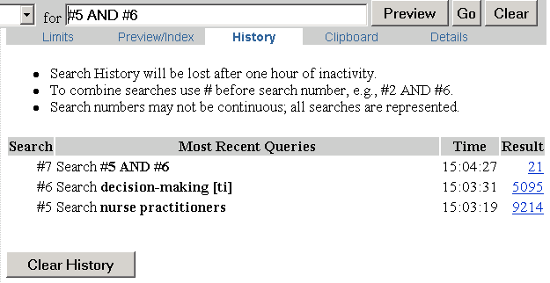

2. Find references to articles about Winston Churchill.

3. Find references to articles indexed with the MeSH headings for video display terminals and carpal tunnel syndrome. Use the Related Articles feature to find similar articles. Combine the list of Related Articles with the publication type, Review. (Hint: Use History.)

History screen:
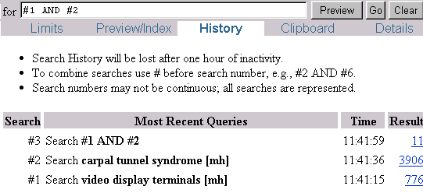

Final History screen:
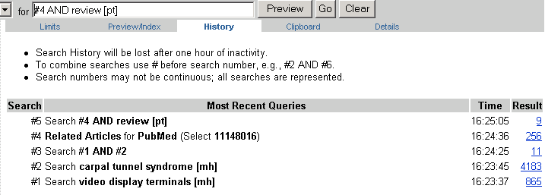

4. Using the MeSH Browser, find citations to articles about the prevention of chickenpox or measles during pregnancy. Combine these results to retrieve English language articles that have abstracts on the PubMed citation.

Detailed Display screen for the MeSH term Chickenpox with the subheading prevention & control selected:

Click on  Add button  to begin to  build your  strategy. | 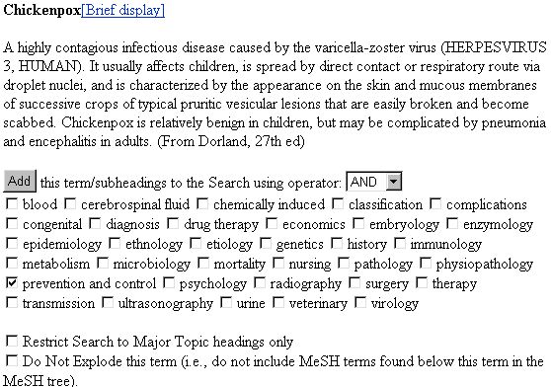

Next, look up measles and display the detailed screen. Select the prevention & control subheading:

Select the OR operator. Then click on the  Add Button. | 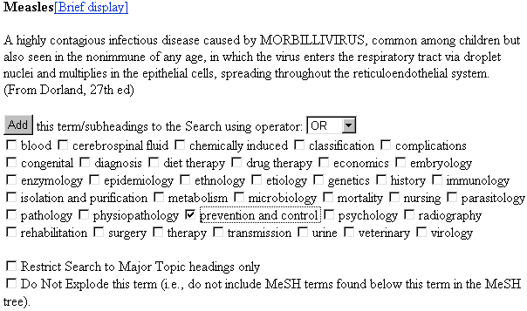
Extra credit hints:
1. Use the [PS] tag.
2. The correct MeSH heading is “Community-Acquired Infections”, use [MH], [SH] and [TIAB] tags for the terms when the official term may be unknown.

Discipline Searching

PubMed has a number of options that make searching in specific disciplines simple. An obvious tool for this kind of searching is the Journal/Citation Subsets menu found on the Limits Screen:

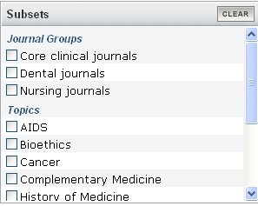

Discipline/Topic Subset choices are

- AIDS Subset - This subset strategy was created to facilitate searching for subjects in the area of AIDS. It is based on search strategies used for creating NLM's AIDSLINE® database. This subset can also be used in a search as aids [sb].

- Bioethics Subset - This subset strategy was created by NLM and the Kennedy Institute of Ethics, Georgetown University to facilitate searching for citations to articles in the area of bioethics. This subset can also be used in a search as bioethics [sb].

- Cancer Subset – This subset strategy was created by NLM and the National Cancer Institute to aid in searching for citations to cancer-related articles. This subset can also be used in a search as cancer [sb].

- Complimentary Medicine – This subset strategy was created by NLM and that National Center for Complementary and Alternative Medicine (NCCAM) and is designed to limit a search to citations in the area of complimentary and alternative medicine. This subset can also be used in a search as cam [sb].

- Dental Journals Subset – This subset can also be used in a search as jsubsetd.

- History of Medicine Subset - This subset strategy was created by NLM's History of Medicine Division to facilitate searching for subjects in the history of medicine. This subset can also be used in a search as history [sb].

- Nursing Journals Subset – This subset strategy was created using the titles found in the International Nursing Index (discontinued in 2000). This subset can also be used in a search as jsubsetn.

- Space Life Sciences Subset - This subset strategy was developed by NLM and the NASA SPACELINE Office and is intended to retrieve citations of interest to those working in the field of space life sciences research. This subset can also be used in a search as space [sb].

- Toxicology Subset - This subset strategy was created by NLM's Specialized Information Services to facilitate searching for subjects in the area of toxicology. This subset can also be used in a search as tox [sb].

- Veterinary Medicine/Animal Health Subset - This newest subset retrieves citations to journal literature, by combining subject search terms, title words, and veterinary and animal health journal titles. This subset can also be used in a search as veterinary[sb]

PubMed also offers other powerful tools for use by the researcher working in a specific discipline: natural language searching, specific MeSH headings and MeSH subheadings. Following are instructions from some sample disciplines.

Veterinary Medicine Discipline Searching

MEDLINE indexes more than 80 titles directly relevant to the veterinary sciences. However, the most commonly used method of searching veterinary topics, limiting to animal subjects, is a wildly inaccurate strategy since this tactic will retrieve citations to articles on the testing of human-oriented applications upon animal subjects.

VETERINARY[SB]: The veterinary medicine subset is not yet listed in limits, but veterinary[sb] may be used in the search box or accessed through “Special Queries”. In addition to using the Veterinary Medicine/Animal Health subset, the searcher may use the veterinary MeSH subheading or one of the various related veterinary MeSH headings

Subset example:

Mitral Valve Insufficiency AND veterinary[sb]

Subheading examples:

Mitral Valve Insufficiency/veterinary[MeSH]
Mitral Valve Insufficiency/veterinary[MeSH] AND dogs[MeSH]

This strategy could also include a free-floating subheading that will bring in veterinary application that does not necessarily attach to the main search topic:

Mitral Valve Insufficiency[mh] AND dogs[mh] AND ve[sh]

Animal Toxicity Studies

One additional source may be important to veterinary searches: the Hazardous Substance Databank. These files may contain any of the following reports related to the effects chemicals have on the animals on which they were tested.

- Non-Human Toxicity Excerpts and/or Values,
- Ecotoxicity Excerpts and/or Values
- Evidence for Carcinogenicity
- National Toxicology Program Studies

Search TOXNET at http://toxnet.nlm.nih.gov/ to find animal toxicity studies in the Hazardous Substance Data Bank. Use the chemical of interest plus the animal, e.g.: warfarin AND dogs

Nursing Discipline Searching

PubMed has a special benefit for nurses in that the Nursing Journal Subset is built into the Limits feature. This subset contains the titles once indexed by the International Nursing Index (INI), which went out of print in 2000. Although the INI is no longer in print, the Nursing Journal Subset continues to be updated in PubMed and may be searched in two different ways: using Limits or the search command JSUBSETN.

- The Limits method involves selecting the Nursing Journal Subset from the subset drop-down box in the Limits feature:

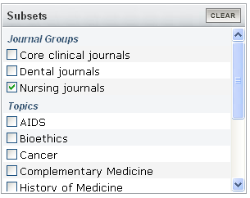

- The search command method involves adding jsubsetn to the search strategy:

Self Care AND jsubsetn

Not all Index Medicus nursing journals are included in the Nursing Journals Subset; therefore, a search limited in this manner will miss these journals; moreover, not all nursing articles are published in nursing journals, so these articles will be missed by this strategy also.

MeSH and Nursing

For a search that extends beyond the nursing journals subset but is specific to the nursing profession, a search strategy can be constructed from MeSH terms instead of using the subset limiter. There are 158 entries in the Permuted MeSH related to the terms "Nurse," "Nurses," and "Nursing." Many are in the MeSH trees under “Nurses” or “Nursing." This means most nursing related subjects may be searched at once by taking advantage of MeSH terms and PubMed's automatic explosion of terms. Other combinations may be found under subjects such as "Philosophy, Nursing." These other combinations do not show up as readily in the MeSH browser, therefore consult the NLM MeSH Browser or print Permuted MeSH.

MeSH Subheadings and Nursing

Of course not all searches about nursing information are about nursing. Some are about nursing aspects of some topic--a disease, or practice, for example. MeSH is useful in this situation by giving one the ability to modify a term with a subject heading. For instance, to get information on care giving in the context of cancer, search on the term "neoplasms" with "nursing" used as a subheading or modifier:

Neoplasms/nursing [mh]

Or

Neoplasms/nu [mh]

As with the veterinary search, the subheading “nursing” or “nu” may be added to a strategy as a free-floating subheading:

Neoplasms[mh] AND nu[sh]

Allied Health Discipline Searching

Searching MEDLINE® for information relevant to allied health professions is not as straightforward as finding literature relevant to nursing or veterinary medicine. The large variety of occupations involved makes the creation of a simple filter unwieldy and undesirable. This section will show how MeSH® maps allied health professions and will aid searchers building queries that effectively retrieve information written (1) about and (2) for these occupations.

As a result of a division between professional and paraprofessional occupations, MeSH has two major categories that are further subdivided into allied health practice: Allied Health Occupations, and Allied Health Personnel. "Allied Health Occupations" belongs under the Biological Sciences/Health Occupations rubric while "Allied Health Personnel" belongs under the "Persons Category." The distinction is academic: audiology is an occupation; an emergency medical technician is a person. Consequently, there are no MeSH terms for audiologist or for emergency medical technology. Following are the two categories and their subordinate headings.

Allied Health Occupations  Audiology  Occupational Therapy  Physical Therapy (Specialty)  Speech-Language Pathology  Technology, Dental  Technology, Medical  Technology, Radiologic  Teleradiology | Allied Health Personnel  Animal Technicians  Community Health Aides  Dental Auxiliaries  Dental Assistants  Dental Hygienists  Dental Technicians  Denturists  Emergency Medical Technicians  Home Health Aides  Medical Record Administrators  Medical Secretaries  Medical Receptionists  Nurses' Aides  Psychiatric Aides  Operating Room Technicians  Pharmacists' Aides  Physician Assistants  Ophthalmic Assistants  Pediatric Assistants

A MEDLINE search for information about a specific allied health field would use the appropriate subcategory. For instance, to find information regarding physician assistants, start with:

Physician Assistants [mh]

The strategy indicated above can be fleshed out to create real searches about the work of physician assistants by adding more terms, either natural language terms or MeSH. To find out the role of physician assistants in nephrology, start with a search strategy that looks like this:

Physician Assistants [mh] AND nephrology
OR
Physician Assistants [mh] AND nephrology [mh]

A number of allied health occupations (see the AMA list at linked from http://www.ama-assn.org/ama/pub/category/2322.html) are missing from MeSH, for instance, recreation therapist, cytotechnologist, perfusionist (perfusion therapist). To search MEDLINE for information on these topics start with this question: may this occupation be found in another branch of the MeSH tree? Medical Illustration is a subcategory by itself under "Health Occupations." While MeSH doesn't recognize Medical Illustration as an Allied Health Occupation, it listed as an occupation.

But what about perfusionists? MeSH recognizes "perfusion" but not the therapists who do the work. Here, it is time to partially abandon MeSH; to initiate a search for articles about perfusionists by entering "Perfusionist" into the PubMed search box without any qualifiers (or perfusionist* to pick up singular or plural):

Perfusionist*

The term is entered without qualifiers. PubMed searches for the word in all fields, including titles and abstracts. All allied health queries may be entered in this way, without the MeSH apparatus, but MeSH allows considerable control in a search strategy. For example, someone interested in the intersection of perfusion therapy and aortic aneurysm in the abdominal region might use a combination of the natural language search above and MeSH terminology:

Perfusionist AND Aortic Aneurysm, Abdominal [MH]

This strategy finds "perfusionist" in title or abstract and the aneurysm in the MeSH field. Oddly, because "perfusionist" is such a specific profession, as are most allied health occupations, this usually scattershot way of searching leads to very precise results. The inclusion of a MeSH recognized condition or disease makes the search even more unambiguous.

The AMA recognizes fifty-three allied health occupations, not all of which are recognized by MeSH. But neither does the AMA recognize all occupations that other associations or schools include in their roster of occupations. What is important to remember is not particularly that MeSH does not measure up, but that MEDLINE remains a great source of bibliographic information for the allied health fields. And not a tremendous amount of skill is required to search with PubMed: know when to use MeSH and when to use natural language and when to use them in tandem.

Pharmacologic Action Headings (PA) and Searching for Drug Information

Part of this is taken from the NLM Technical Bulletin
See http://www.nlm.nih.gov/pubs/techbull/ja03/ja03_papx.html for the entire article.

In 1996, the MeSH Tree Structure was changed so that specific drugs/chemicals were no longer treed under a function (pharmacological action) heading. This means that in MeSH there is no branch containing all drugs with a particular effect (e.g., all the antioxidants).

The old PubMed MeSH browser displayed the associated drug/substance terms under the respective action term in the hierarchical display – even though these indentions did not really exist in the MeSH tree structure.

Changes to PubMed:

  - PubMed’s MeSH Database includes only those indentions for PA terms found in the actual MeSH tree structure – not (as before) terms that had the effect, but were not true indentions.

  - Search with [PA]: A new search tag, [PA], and a new index of Pharmacological Action terms been created. See this index using the Preview/Index function in PubMed. Use of a term with this tag instructs PubMed to OR together terms from a list made up of a PA term and the drug/substance terms known to have that effect. This includes both MeSH headings and terms for Supplementary Concept Records. Any MeSH terms on the lists are searched with the no explode specification [mh:noexp], so as not to include any possible indentions of the term that might not share the pharmacologic action. Use this search method when you want to include retrieval for all MeSH terms with a particular action. For example: neoplasms[mh] AND antioxidants[pa]

  - Pharmacologic Action Lists: To see what substances are included in a PA list, either the NLM MeSH browser or the PubMed MeSH database may be used.
- In the NLM MeSH browser, enter a PA term, click “Pharmacological Action [PA]”, and then click “Find exact term.”
- In the PubMed MeSH browser, enter a PA term in the search box and then look for the “[pharmacological action]” tag following the term in the results.

  - Search with [MH]: Terms tagged with [MH] will retrieve the term and the true indentions (due to automatic exploding of terms). This allows searchers to retrieve citations about a drug or substance with a specific action back through 1996.

  - Search with no tag: If you enter a MeSH heading (or an entry term) that happens to be a Pharmacologic Action Term and do not use a search tag, PubMed will automatically search the term as [MH], [PA], and [TW].
NOTE: Prior to the 1996 MeSH year, NLM treed specific drugs/substances under the pharmacologic action MeSH heading. Indexing policy stipulates that indexers assign the most specific heading; a broader heading is typically not added. Therefore, citations to articles about pharmacologic actions indexed before 1996 usually carry only the specific drug/substance heading and not the pharmacologic action heading. If you need comprehensive searches to include citations for articles indexed before 1996, do a search for the substance ANDed with the PA term as well as a search for the substance alone, i.e., do not combine with PA term.

Some additional information about searching for drug information in PubMed:

- MeSH indexes drug names under their generic names (US Adopted Name), not their brand names. However, brand names will oftentimes map to the appropriate generic name. Note that MeSH favors American rather than British names. If a drug name does not map to a MeSH term, it may map to a Substance Name (Supplementary Concept Record).

Prozac will map to the MeSH term fluoxetine.
Paracetamol will map to the MeSH term acetaminophen
Exelon will map to the Substance Name rivastigmine

  - A drug name typed into the search box in PubMed may automatically map to the appropriate Descriptor or Substance Name – this may not happen with very new drug or substance names. Remember to check the Details box to see how a given term maps.

- Search by Substance Name. Enter the name of the substance in the search box followed by [NM]. This will search the “Substances” field in the PubMed record.

Oxycodone[NM] “noradrenaline transporter”[NM]
Analgesics[NM] sodium[NM]

- CAS numbers may be used to search. Either input the CAS number into the search box and hit enter or qualify your search with the tag [EC/RN number].

Either of these two searches will retrieve information on simvastatin:
79902-63-9
79902-63-9 [RN]

- Research codes may be used to search for drugs in early investigational stages. In many cases, this will be a text word search and will only be successful if the research code appears in the title or abstract. However, later, the research code will be an entry term for MeSH and will map to the appropriate drug name.

MK-639 will map to Indinavir (Crixivan)

- When searching for drugs that may be used to treat a particular condition, use the MeSH term for the condition and the subheading DT (drug therapy).

Hypertension/dt

- If a condition is caused by a drug, use the MeSH term for the condition along with the subheading CI (chemically induced).

Dyskinesias/ci

- To search for the effects of a drug on an organ or physiologic process, use the MeSH term for the organ or physiologic process and add the subheading de (drug effects). Or, combine AE (adverse effects – referring to the drug causing adverse effects) with CI (chemically induced – referring to a condition caused by a drug). Using the proper MeSH/subheading combinations can effectively narrow a search.

Acetaminophen AND liver/de
Heparin/ae AND thrombocytopenia/ci

Pharmacological Actions [PA]

Use a known pharmacological action with [PA].
Example: androgens [PA].

Abortifacient Agents, Nonsteroidal | Abortifacient Agents, Steroidal | Adhesives
Adjuvants, Anesthesia | Adjuvants, Immunologic | Adjuvants, Pharmaceutic
Adrenergic Agents | Adrenergic Agonists | Adrenergic alpha-Agonists
Adrenergic alpha-Antagonists | Adrenergic Antagonists | Adrenergic beta-Agonists
Adrenergic beta-Antagonists | Adrenergic Uptake Inhibitors | Aerosol Propellants
Affinity Labels | Agglutinins | Air Pollutants
Air Pollutants, Environmental | Air Pollutants, Occupational | Air Pollutants, Radioactive
Alcohol Deterrents | Aldosterone Antagonists | Alkylating Agents
Amebicides | Anabolic Agents | Analgesics
Analgesics, Non-Narcotic | Analgesics, Opioid | Androgen Antagonists
Androgens | Anesthetics | Anesthetics, Combined
Anesthetics, Dissociative | Anesthetics, Inhalation | Anesthetics, Intravenous
Anesthetics, Local | Angiogenesis Inducing Agents | Angiogenesis Inhibitors
Angiotensin II Type 1 Receptor Blockers | Angiotensin-Converting Enzyme Inhibitors | Anion Exchange Resins
Antacids | Anthelmintics | Anti-Allergic Agents
Anti-Anxiety Agents | Anti-Arrhythmia Agents | Anti-Asthmatic Agents
Anti-Bacterial Agents | Anti-Dyskinesia Agents | Anti-HIV Agents
Anti-Infective Agents | Anti-Infective Agents, Local | Anti-Infective Agents, Urinary
Anti-Inflammatory Agents | Anti-Inflammatory Agents, Non-Steroidal | Anti-Obesity Agents
Anti-Ulcer Agents | Antibiotics, Antifungal | Antibiotics, Antineoplastic
Antibiotics, Antitubercular | Anticarcinogenic Agents | Anticestodal Agents
Anticholesteremic Agents | Anticoagulants | Anticonvulsants
Antidepressive Agents | Antidepressive Agents, Second-Generation | Antidepressive Agents, Tricyclic
Antidiarrheals | Antidiuretic Agents | Antidotes
Antiemetics | Antifibrinolytic Agents | Antifoaming Agents
Antifungal Agents | Antihypertensive Agents | Antilipemic Agents
Antimalarials | Antimanic Agents | Antimetabolites
Antimetabolites, Antineoplastic | Antimutagenic Agents | Antinematodal Agents
Antineoplastic Agents | Antineoplastic Agents, Alkylating | Antineoplastic Agents, Hormonal
Antineoplastic Agents, Phytogenic | Antioxidants | Antiparasitic Agents
Antiparkinson Agents | Antiplatyhelmintic Agents | Antiprotozoal Agents
Antipruritics | Antipsychotic Agents | Antirheumatic Agents
Antisickling Agents | Antispermatogenic Agents | Antithyroid Agents
Antitreponemal Agents | Antitrichomonal Agents | Antitubercular Agents
Antitussive Agents | Antiviral Agents | Appetite Depressants
Appetite Stimulants | Aromatase Inhibitors | Astringents
Biocompatible Materials | Biological Response Modifiers | Blood Substitutes
Bone Cements | Bone Density Conservation Agents | Bronchoconstrictor Agents
Bronchodilator Agents | Buffers | Calcium Channel Agonists
Calcium Channel Blockers | Carbonic Anhydrase Inhibitors | Carcinogens
Carcinogens, Environmental | Cardiotonic Agents | Cardiovascular Agents
Cariogenic Agents | Cariostatic Agents | Cathartics
Caustics | Central Nervous System Agents | Central Nervous System Depressants
Central Nervous System Stimulants | Chelating Agents | Chemical Warfare Agents
Chemosterilants | Cholagogues and Choleretics | Cholinergic Agents
Cholinergic Agonists | Cholinergic Antagonists | Cholinesterase Inhibitors
Cholinesterase Reactivators | Chromogenic Compounds | Coagulants
Coccidiostats | Coloring Agents | Complement Inactivating Agents
Contraceptive Agents | Contraceptive Agents, Female | Contraceptive Agents, Male
Contraceptives, Oral | Contraceptives, Oral, Combined | Contraceptives, Oral, Hormonal
Contraceptives, Oral, Sequential | Contraceptives, Oral, Synthetic | Contraceptives, Postcoital
Contraceptives, Postcoital, Hormonal | Contraceptives, Postcoital, Synthetic | Contrast Media
Convulsants | Cross-Linking Reagents | Cryoprotective Agents
Culture Media | Cyclooxygenase Inhibitors | Cysteine Proteinase Inhibitors
Cytotoxins | Defoliants, Chemical | Delayed-Action Preparations
Dental Disinfectants | Dental Materials | Dentifrices
Deodorants | Dermatologic Agents | Dermotoxins
Detergents | Disinfectants | Diuretics
Diuretics, Osmotic | Dopamine Agents | Dopamine Agonists
Dopamine Antagonists | Dopamine Uptake Inhibitors | Drug Carriers
Emetics | Emollients | Endocannabinoids
Endothelium-Dependent Relaxing Factors | Environmental Pollutants | Enzyme Activators
Enzyme Inhibitors | Estradiol Antagonists | Estrogen Antagonists
Estrogen Receptor Modulators | Estrogens | Estrogens, Non-Steroidal
Excipients | Excitatory Amino Acid Agonists | Excitatory Amino Acid Antagonists
Expectorants | Fat Substitutes | Fertility Agents, Female
Fertility Agents, Male | Fertilizers | Fibrinolytic Agents
Filaricides | Fixatives | Flavoring Agents
Fluorescent Dyes | Folic Acid Antagonists | Food Additives
Food Coloring Agents | Food Preservatives | Free Radical Scavengers
Fungicides, Industrial | GABA Agents | GABA Agonists
GABA Antagonists | GABA Modulators | Ganglionic Blockers
Ganglionic Stimulants | Gastrointestinal Agents | Glucocorticoids
Glycine Agents | Gout Suppressants | Growth Inhibitors
Growth Substances | GTP Phosphohydrolase Activators | Hallucinogens
Hazardous Substances | Hemagglutinins | Hematinics
Hematologic Agents | Hemostatics | Heparin Antagonists
Herbicides | Histamine Agents | Histamine Agonists
Histamine Antagonists | Histamine H1 Antagonists | Histamine H1 Antagonists, Non-Sedating
Histamine H2 Antagonists | HIV Fusion Inhibitors | HIV Protease Inhibitors
Hormone Antagonists | Hormones | Hydroxymethylglutaryl-CoA Reductase Inhibitors
Hypnotics and Sedatives | Hypoglycemic Agents | Immunologic Factors
Immunosuppressive Agents | Immunotoxins | Indicators and Reagents
Insect Repellents | Insecticides | Insulin Antagonists
Intercalating Agents | Interferon Inducers | Iodophors
Ionophores | Iron Chelating Agents | Irritants
Keratolytic Agents | Leprostatic Agents | Leukotriene Antagonists
Lipotropic Agents | Lipoxygenase Inhibitors | Luminescent Agents
Luteolytic Agents | Membrane Transport Modulators | Menstruation-Inducing Agents
Miotics | Mitogens | Molecular Probes
Molluscacides | Monoamine Oxidase Inhibitors | Mouthwashes
Muscarinic Agonists | Muscarinic Antagonists | Muscle Relaxants, Central
Mutagens | Mydriatics | Myeloablative Agonists
Narcotic Antagonists | Narcotics | Nasal Decongestants
Natriuretic Agents | Neuromuscular Agents | Neuromuscular Blocking Agents
Neuromuscular Depolarizing Agents | Neuromuscular Nondepolarizing Agents | Neuroprotective Agents
Neurotoxins | Neurotransmitter Agents | Neurotransmitter Uptake Inhibitors
Nicotinic Agonists | Nicotinic Antagonists | Nitric Oxide Donors
Nootropic Agents | Nucleic Acid Synthesis Inhibitors | Ointment Bases
Oligonucleotides, Antisense | Ophthalmic Solutions | Oxidants
Oxidants, Photochemical | Oxytocics | Parasympatholytics
Parasympathomimetics | Peroxisome Proliferators | Pesticide Synergists
Pesticides | Pharmaceutic Aids | Phosphodiesterase Inhibitors
Photoaffinity Labels | Photosensitizing Agents | Phytoestrogens
Plant Growth Regulators | Plasma Substitutes | Plasticizers
Platelet Aggregation Inhibitors | Poisons | Potassium Channel Blockers
Preservatives, Pharmaceutical | Progestins | Prostaglandin Antagonists
Protease Inhibitors | Protective Agents | Protein Kinase Inhibitors
Protein Synthesis Inhibitors | Psychotropic Drugs | Pulmonary Surfactants
Pyrogens | Radiation-Protective Agents | Radiation-Sensitizing Agents
Radiopharmaceuticals | Reducing Agents | Respiratory System Agents
Reverse Transcriptase Inhibitors | Riot Control Agents, Chemical | Rodenticides
Schistosomicides | Sclerosing Solutions | Selective Estrogen Receptor Modulators
Serine Proteinase Inhibitors | Serotonin Agents | Serotonin Agonists
Serotonin Antagonists | Serotonin Uptake Inhibitors | Siderophores
Sodium Channel Blockers | Sodium Chloride Symporter Inhibitors | Sodium Potassium Chloride Symporter Inhibitors
Soil Pollutants | Solvents | Spermatocidal Agents
Sulfhydryl Reagents | Sunscreening Agents | Surface-Active Agents
Sweetening Agents | Sympatholytics | Sympathomimetics
Tear Gases | Teratogens | Tissue Adhesives
Tocolytic Agents | Toothpaste | Trace Elements
Tranquilizing Agents | Trypanocidal Agents | Trypsin Inhibitors
Uncoupling Agents | Uricosuric Agents | Vasoconstrictor Agents
Vasodilator Agents | Vehicles | Vitamin B Complex
Vitamins
http://www.ncbi.nlm.nih.gov/entrez/query.fcgi?cmd=Retrieve&db=mesh&list_uids=1000082&dopt=Full

My NCBI

- Allows users to customize their search experience in PubMed
- Allows users to save search strategies
- Allows PubMed to update those saved searches on a schedule of the user’s choosing and send the results to the user via email

Setting up a My NCBI account:

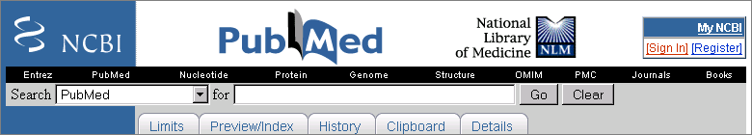

Click on register and follow the instructions, choosing a username and password.

Write down your username and password as well as the answer to the security question. While PubMed can send passwords to users who have forgotten them, usernames cannot be recovered for those who have forgotten this information.

Watch for the verification email from PubMed. Respond to it. If you do not verify your email address, no automatic updates will be sent.

Once the account has been registered, the My NCBI box will change to a Welcome:



Your My NCBI account is now ready for customization. Start by clicking on the My NCBI link either in the upper right-hand box or on the left navigation bar:

This will take you to your account’s web page. Look for the logo in the upper left hand corner: | 
On the left hand side of the screen, you’ll see various options: | 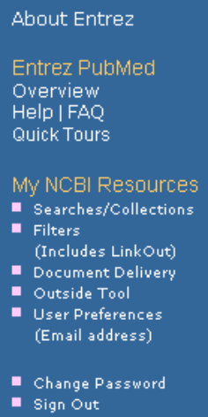

My NCBI allows you to customize your PubMed searching:

- Save searches. Do you have a specific subject that you monitor? Set up the search once and then let PubMed email you, automatically, new citations that meet your search criteria.

- Build Collections. Are you writing an article or creating a presentation and building a bibliography? Collect PubMed citations in one web-accessible place.

- Set filters. Set limits to your searches once and see them every time you search PubMed using your My NCBI account. My NCBI has over 70 different filters available.

- User Preferences. Enter your preferred email address once and then, every time you want to email citations using the “Send To Email” in PubMed, that email address will appear as the default address. Type once – use over and over and over again via My NCBI. This is also the email address to which your saved searches will be sent.

Setting Filters in My NCBI | 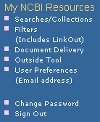
1. Click on Filters on the blue side bar:

2. Choose which database you want to work in – Click on PubMed:

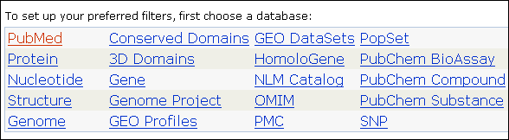

3. Configure “Quick Picks” by clicking the desired boxes to check or uncheck the filter:

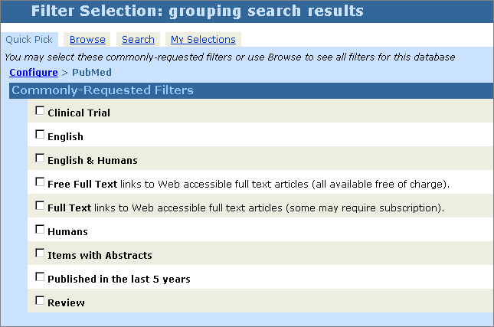
For example, if English and Free Full Text are checked, whenever you are signed into your My NCBI account and PubMed is searched, two new tabs will show up:

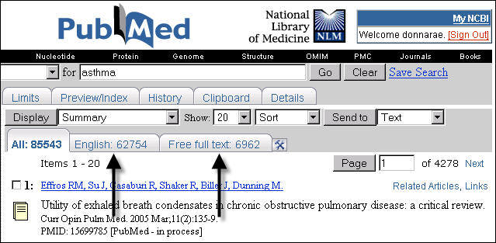

Here, it is quickly apparent that out of the 85,543 results there are 62,754 in English. See them by clicking on the English tab. There 6,962 items that have free full text available. See that set by clicking on the Free Full Text tab. (Remember, these may not be all the journals free for those working through a library.)

4. Click on the “Browse” tab in the My NCBI page to find other available filters:

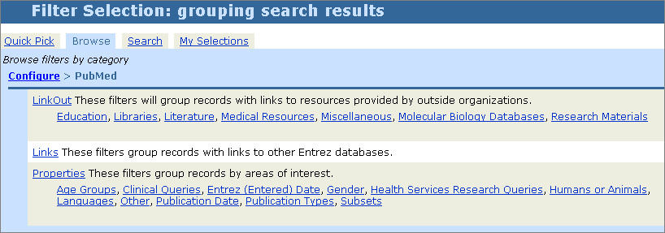

Simply add filters as desired. NOTE: Only 5 filters may be active at any one time.

LinkOut for Libraries and My NCBI

Many libraries have provided online access to electronic journals for faculty, staff, and students via LinkOut for Libraries. To see these easily, set up a filter. Instructions follow for setting up the filter.

1. From the Browse Filters page (graphic above) click on Libraries.

2. A new screen will appear. Scroll down to find your library’s name in the list. Click on the blue hyperlink (the school name, not the globe).
Example: Find U Mass Medical School in the list:

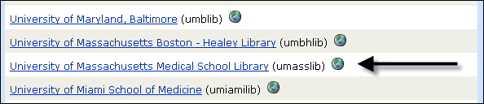

3. From the next screen that pops up, click on “Add a result tab…” and “Add a link icon…”

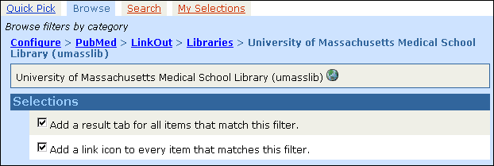

4. Done! The filter has been set. Now, whenever you search PubMed after signing into your My NCBI account, this is what you’ll see:

[graphic on next page]

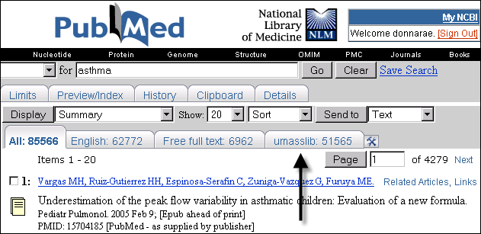

 | In order to read the full text, patrons must be accessing PubMed through the special LinkOut URL for the specified library or via a proxy server.

Libraries that participate in LinkOut for Libraries may wish to set up a Shared My NCBI account so that the LinkOut Filter for their library will automatically display anytime someone accesses PubMed via their special LinkOut URL.

See the NLM Technical Bulletin article, “Share My NCBI Account Settings,” for instructions on how to do this. http://www.nlm.nih.gov/pubs/techbull/ja05/ja05_share_my_ncbi.html

Also, libraries are now able to change the wording on their library’s LinkOut filter tab. See the NLM Technical Bulletin technical note, “Choosing a Display Name for the Filter Tab in PubMed,” at http://www.nlm.nih.gov/pubs/techbull/so05/so05_technote.html#10
For more information on LinkOut, visit: http://www.ncbi.nlm.nih.gov/projects/linkout/

NOTE: Filter selections may be changed using either the “My Selections” link in the navigation bar or by clicking the icon on the PubMed page.

Saving Searches in My NCBI

My NCBI will save search strategies. This is different from the Clipboard which saves search results. Once saved, a search strategy may be set up for automatic updates. Here’s the process:
1. Set up and run your search in PubMed. Then, click on the Save Search link:

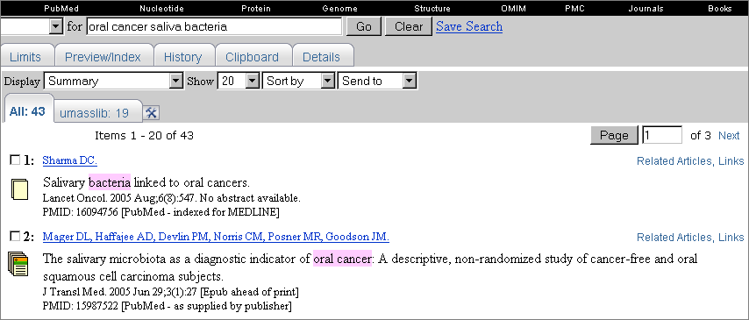

2. A new window will open:

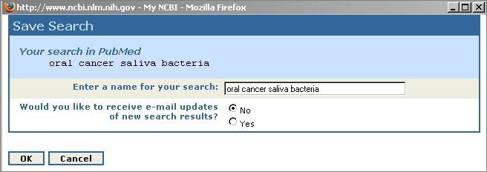

A default name for the search is offered which may be changed.
Clicking on OK at this point will save the search and it may be manually updated at any time.

3. Click on Yes for automatic emailed updates of new search results. Now, set up the schedule:

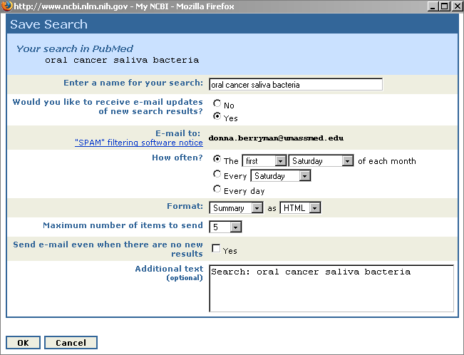

When finished, click OK.

 | Name the search | Naming the search will not affect the search strategy. The name will be part of the subject line of the emailed updates.
 | Schedule | May be changed at any time
 | HTML or Text? | Depends on your email system. If your system is text based, change this setting to text. For live links to all results, use the HTML setting.
 | Maximum number of items to send | Select high enough so as not to miss any important articles.
 | Additional Text | This will appear in the emailed updates as: Sender’s Message

My Saved Searches page

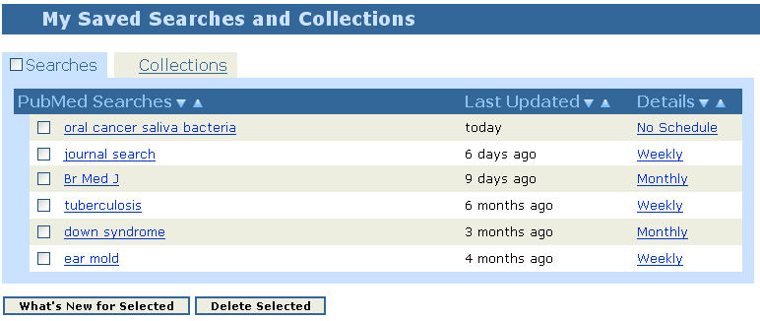

- Access saved searches by clicking on the My NCBI link, then on the Searches tab.

- Manually update searches using this page. Select a search by checking the box adjacent to a search, then click on the What’s New for Selected button.

- See search strategies by mousing over the search name in the first column.

- Click on the search name hyperlink in the first column to retrieve total search results – this will not affect any scheduled updates, but retrieval will not be limited to just new results.

- See next scheduled update by mousing over entry in the “Last Updated” column.

- See schedule for updates by mousing over the entry in the “Details” column.

- Change the schedule for updating a search by clicking on the entry in the “Details” column.

- Delete a search or searches by checking the box adjacent to a search and then clicking on the Delete Selected button.

- Up to 100 searches may be saved.

Out with the old, in with the new.

Saved search strategies can NOT be edited.

Delete the old strategy. Plan your new strategy, run it in PubMed, then save it in My NCBI.

Saving Collections in My NCBI

In addition to search strategies, collections of citations may be saved. Saving the selected results of searches to permanent collections is a two-step process: results are first sent to the Clipboard and then to a My NCBI Collection. Generally, the web browser should accept NCBI pop-ups (http://www.ncbi.nlm.nih.gov/) for this to work properly.

- Run a PubMed search. On the results page select the citations to be saved using the check boxes; if no items are selected, all results up to 500 items will be sent to the clipboard

- From the Display line, use the Send To drop-down menu and click on Clipboard

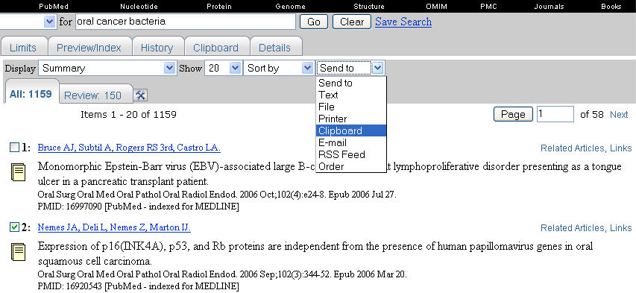

- After moving all desired citations to the clipboard, click the Clipboard tab. Select citations to be saved to the Collection. Note: if no items are selected, all results will be saved.

- Select My NCBI Collections under the Send To menu. A pop-up window will appear or use the alternative link provided

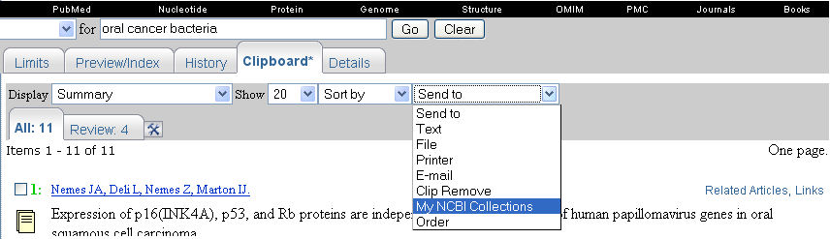

- In the Save Collection pop-up window, there are two options: create and name a new collection or append the results to an existing collection.

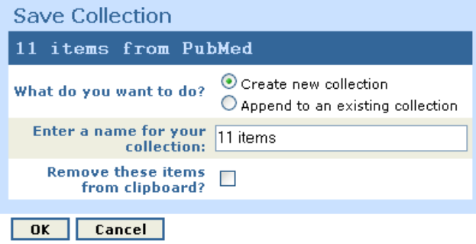

- The citations may be deleted from the Clipboard if they are no longer needed.

My Collections Page

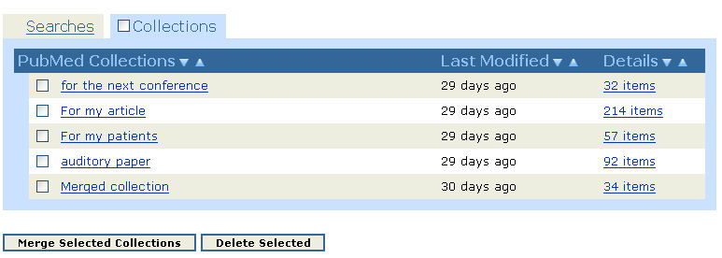

- Access collections by clicking on the My NCBI link, then on the Collections tab.

- Click on the link in the first column to moved the collection to a result page and allows them to be sent to, for example, email or save to a file.

- Merge collections by checking the box and clicking “Merge Selected Collections”. The new collection may be given a new name and, if desired, the original collections may be deleted.

- Delete collections by checking the box and clicking “Delete Selected”.

- See the date the collection was last updated by mousing over entry in the “Last Modified” column.

- Click on the link in the “Details” column to change the name of the collection and to access and/or delete individual citations.

- Each collection may have up to 1500 items; each My NCBI account may have up to 100 collections.

Preferences in My NCBI

Use Preference in My NCBI to:

- Change the email address used for the account.
- Change the way the links display in PubMed.
- Turn on (or off) the highlighting feature in PubMed.
- Choose the format for displaying single citations in PubMed (the default is Abstract Plus).

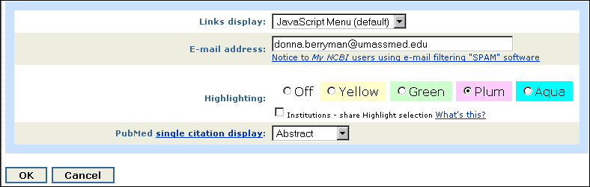

LinkOut

LinkOut provides links from PubMed and other Entrez databases to a wide variety of relevant web-accessible online resources including, but not limited to, full text.

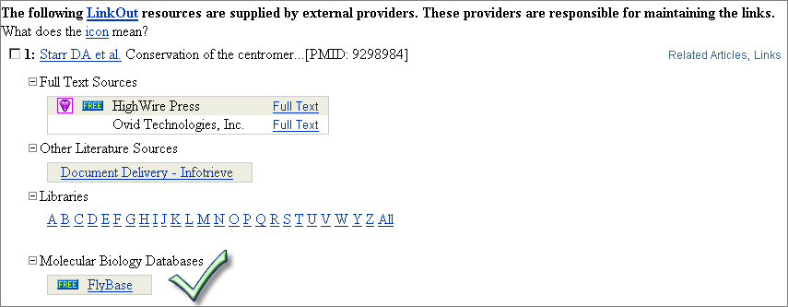
Exercises

Using My NCBI

1. A health professional you work with has library privileges both at the Forsyth Institute and Harvard Medical school. How would you help them set up a My NCBI account that would show both sets of holdings?

2. The family of a child with Marfan syndrome makes quarterly trips to the child’s specialist for check-ups. Help them save a search that will automatically give them updates concerning this syndrome.

3. Several people on your staff are working on an article; how would it be possible to make the citations necessary available to all of them?

4. A librarian is interested in marketing services to administration in order to strengthen the presence of the library in a small hospital. How could this librarian use My NCBI in this instance?

Using LinkOut:

1. Locate a clinical synopsis of fatal familial insomnia.

2. Does the University of Minnesota Bio-Medical Library have access to the article “Dentist on TV”? If it does, what format is this article available in?

3. What is the melting point of warfarin?

4. Find a Community of Science author profile for Trisha Greenhalgh. In what year did she receive the Order of the British Empire?

Searching with Clinical Queries

Clinical Queries, located on the Sidebar, is PubMed’s Evidence-Based Medicine (EBM) filter-set based upon research done by R. Brian Haynes, MD, PhD at McMaster University. This set consists of the Clinical Queries filters and the Systematic Reviews subset.

Search by Clinical Study Category

The MeSH definition for Evidence-Based Medicine is:

The process of systematically finding, appraising, and using contemporaneous research findings as the basis for clinical decisions. Evidence-based medicine asks questions, finds and appraises the relevant data, and harnesses that information for everyday clinical practice. Evidence-based medicine follows four steps: [1]formulate a clear clinical question from a patient's problem; [2]search the literature for relevant clinical articles; [3]evaluate (critically appraise) the evidence for its validity and usefulness; [4]implement useful findings in clinical practice. The term "evidence based medicine" (no hyphen) was coined at McMaster Medical School in Canada in the 1980's to label this clinical learning strategy, which people at the school had been developing for over a decade. (From BMJ 1995;310:1122) Year introduced: 1997.

Following this definition, the purpose of these filters is to aid clinicians (and librarians!) to perform step 2, “search the literature for relevant clinical articles.” To this end, hedges were established, using the McMaster work to search for contemporaneous research-based literature.

A hedge or filter is a “permanent,” standardized search strategy (usually often used) intended to be used in combination with other ad hoc searches.

Clinical Queries provides these hedges for five clinical situations:

- Therapy: Treatment of a disease or condition.
- Diagnosis: Determination of the nature of a disease or condition or the distinguishing of one disease or condition from another.
- Etiology: (Also known as Harm.) Causation of a disease or condition.
- Prognosis: Prediction of the probable outcome of a disease based on a individual's condition and the usual course of the disease as seen in similar situations.

- Clinical Prediction Guides: Pertain to the prediction of some aspect of a disease or condition and have been advocated as a mechanism for enhancing clinical judgment. Clinical prediction studies develop or validate rules, guides, indexes, equations, scales, scores or models to predict a diagnosis, prognosis, risk (etiology), therapeutic response, therapeutic drug level or clinical outcome.

Additionally, Clinical Queries provides two emphasis filters:

- Narrow, specific search
- Broad, sensitive search

The result of a Clinical Queries filter search is, especially when an emphasis of Specificity is applied, a substantial decrease in retrieval set. However, the set is restricted to research-based citations.

Example:
A PubMed search on using statins in the treatment of diabetic patients who have heart disease:

Search PubMed using the terms: statins heart disease diabetes

Results = 635 hits. Included in those hits are 5 editorials and 8 letters; additionally, there are hundreds of non-research-based articles.

Search Clinical Queries with the terms: statins heart disease diabetes
Use: Therapy
Narrow, specific search

Results = 98 hits. None are editorials or letters. Most articles are research-based. There is an obvious narrowing of retrieval based on the “hedge” supplied by Clinical Queries

Tips for using Clinical Queries:

- Clinical Queries defaults to Therapy and narrow, specific searches.
- If a narrow, specific search retrieves too few citations, use the broad, sensitive emphasis instead.
- While natural language searches often work best in the Clinical Queries interface, MeSH terminology can be used to reduce large retrieval sets, for example: “Heart Diseases [MH] AND Diabetes Mellitus[MH].”
- Remember that the MeSH database contains a Links menu with a “Clinical Queries” option. If clicked, this will send a chosen MeSH term directly to the Clinical Queries search box.
- Copy and paste a search from the MeSH database into the Clinical Queries search box for more control.

Find Systematic Reviews

The Systematic Reviews strategy is intended to retrieve citations identified as systematic reviews, meta-analyses, reviews of clinical trials, evidence-based medicine, consensus development conferences, guidelines, and citations to articles from journals specializing in review studies of value to clinicians.

A systematic review is “a summary of the medical literature that uses explicit methods to perform a thorough literature search and critical appraisal of individual studies and that uses appropriate statistical techniques to combine these valid studies.” (Sackett, et al, 2000.) Meta-analyses are also systematic reviews but they use quantitative methods (statistics) to summarize results.

Systematic reviews may also be searched by adding systematic[sb] to any PubMed search strategy.

Some Evidence-Based Medicine Resources

McKibbon, Ann, Angela Eady, Susan Marks. (1999). PDQ: Evidence-Based Principles and Practice. Saint Louis: B.C. Decker Inc.

Sackett, David L, Sharon E. Straus, W. Scott Richardson, William Rosenberg, R. Brian Haynes. (2000). Evidence-Based Medicine: How to Practice and Teach EBM. New York: Churchill Livingstone.

McLucus, Katherine. (2003). A Student’s Guide to the Medical Literature. Denver: University of Colorado Health Sciences Center, Dennison Memorial Library. Retrieved June 3, 2003 from http://denison.uchsc.edu/SG/ (PDA version available at http://denison.uchsc.edu/SG/PDA.html).

There are also numerous websites available with information regarding EBM:

Evidence Based Medicine: Tutorial http://www.hsl.unc.edu/services/tutorials/ebm/welcome.htm#top
Duke University Medical Center Library and Health Sciences Library, University of North Carolina at Chapel Hill.

Evidence Based Medicine: Information and tutorial
http://library.umassmed.edu/EBM/
Lamar Soutter Library, U Mass Medical School

Centre for Evidence Based Medicine (CEBM)
http://www.cebm.net/index.asp
Medical Genetics Searches

Again, this provides a set of hedges or filters aimed at narrowing retrieval. The hedges were developed in conjunction with the staff of GeneReviews: Genetic Disease Online Reviews at GeneTests, University of Washington, Seattle.

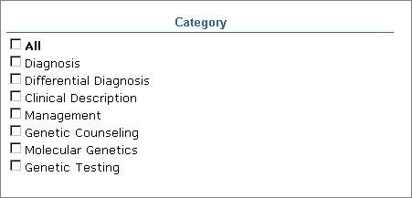

Please note that the default is to have all the listed categories checked. It may be useful to turn off the default and simply select the categories that may be most relevant to your search.

Special Queries

Special Queries, located just below Clinical Queries on the Sidebar, links to other useful hedges and pre-formulated strategies. Use this feature to easily locate these topics:

- Clinical Queries
- Health Services Research (HSR) Queries
- Cancer Topic Searches
- Healthy People 2010
- Subjects Searches (including those not yet in Limits)
AIDS, Bioethics, Cancer, Complementary Medicine, Health Literacy, History of Medicine, Space Life Sciences, Smallpox, Toxicology, Veterinary Medicine/Animal Health
- Additional Search Queries / Interfaces
ALTBIB, CAM on PubMed, MedlinePlus Health Topics, National Institutes of Health Funding Support, Retracted Publication, TOXNET
- Journal Collections

Creating Web Links to PubMed

The Entrez system allows for the creation of URL links that search and retrieve documents from PubMed in three ways:

- Entrez Utilities – These are generally used by researchers who are primarily looking to pull large amounts of sequence data from NCBI databases. See http://www.ncbi.nlm.nih.gov/entrez/query/static/eutils_help.html for more information. NLM also offers classes in this sort of scripting
- The URL button on the details screen – which saves a particular search strategy as a specific URL and will, on command, execute that specific PubMed search
- Manually constructed URLs.

Manually created URL links may be stored on a library website.
- Want to put a section on your library’s website that says, “Click here for current information on avian flu”? Writing a manual link to PubMed can allow you to do that.
- Want to put a section on your library’s web page that says “PubMed articles by our faculty”? Writing a manual link to PubMed can allow you to do just that.
- These links can be use for finding every article on a given topic, through a date range, or for creating current awareness searches that find articles published in a given number of past days.

Complete instructions for writing web links to PubMed can be found at
http://www.ncbi.nlm.nih.gov/entrez/query/static/linking.html

Begin a URL with the NCBI address, a search command, and a choice of database:
http://www.ncbi.nlm.nih.gov/entrez/query.fcgi?cmd=Command&db=Database&…
For our purposes, Command is Search and Database is PubMed. For example, this is the beginning of a PubMed search query:
http://www.ncbi.nlm.nih.gov/entrez/query.fcgi?cmd=search&db=pubmed&…
[A variety of search commands for use with PubMed in conjunction with Entrez’s molecular biology databases exist but are beyond the scope of this lesson; for more information go to http://www.ncbi.nlm.nih.gov/entrez/query/static/linking.html.]

Spaces within a URL cause problems for many web browsers. Convert them to “+” signs, for example, Helv Chim Acta becomes Helv+Chim+Acta.

To specify search strategies, display formats, and date range, other pieces of syntax, may be added to the URL. Of special interest are Term, Doptcmdl, and the Pmfilter family.

Searching

Term permits the addition of search terms such as MeSH terms, subheadings, natural language terms, and field tags. Nesting of searches may also be done using Term. The syntax for term is:
&term=
Example:
http://www.ncbi.nlm.nih.gov/entrez/query.fcgi?cmd=search&db=pubmed&term=
- Use &term to perform simple searches:
&term=food+hypersensitivity
- Field tags may also be used:
&term=food+hypersensitivity[mh]+AND+2002[pdat]
&term=food+hypersensitivity[mh]+AND+cam[sb]
(this limited the search to the Complimentary Medicine Subset)
- Nesting is similar to nesting done in the PubMed search box:
&term=(bronchitis+OR+asthma)+AND+(drug+therapy+OR+diet+therapy)
- Phrase searching may be forced, by using a combination of double quote marks and + signs:
&term=“food+hypersensitivity”

Formats
Doptcmdl lets the searcher determine the PubMed format of the search. The syntax of the search is:
&doptcmdl=format
where format is one of the following for PubMed (see Entrez Help for information on other Entrez databases by clicking on the Help link or searching “All NCBI Help” from the online PubMed Help manual):

DocSum | Brief | Abstract | Citation
MEDLINE | XML | ASN.1∗ | ExternalLink**

Example:
To search for articles on Coronary Artery Bypass in MEDLINE format use the following syntax:
http://www.ncbi.nlm.nih.gov/entrez/query.fcgi?cmd=search&db=pubmed
&term=food+hypersensitivity&doptcmdl=medline

Date Ranges

Pmfilter is the family of filters used to limit a search between two dates. The dates can be fixed or relative.
Fixed Dates
Use this sequence of commands to limit a search between two specific dates.
- cmd=Search
- term=food+hypersensitivity [search strategy]
- db=pubmed [database choice]
- orig_db=pubmed [=database choice above]
- pmfilter_DateRange_Field=Publication+date [determines the kind of date filtering to be done]
- filters=on [turns filtering on]
- pmfilter_DateRange_MinYear=YYYY [year of beginning date]
- pmfilter_DateRange_MinMonth=MM [month of beginning date]
- pmfilter_DateRange_MinDay=DD [day of beginning date]
- pmfilter_DateRange_MaxYear=YYYY [year of termination date]
- pmfilter_DateRange_MaxMonth=MM [month of termination date]
- pmfilter_DateRange_MaxDay=DD [day of termination date]

Example:
To search PubMed for citations on the MeSH term food hypersensitivity from 200/01/30 to 2001/12/01 enter:
http://www.ncbi.nlm.nih.gov/entrez/query.fcgi?
cmd=search&db=pubmed&orig_db=PubMed&term=food+hypersensitivity[mh]
&filters=on&pmfilter_DateRange_Field=Publication+Date
&pmfilter_DateRange_MinYear=2000&pmfilter_DateRange_MinMonth=01
&pmfilter_DateRange_MinDay=30
&pmfilter_DateRange_MaxYear=2001&pmfilter_DateRange_MaxMonth=12
&pmfilter_DateRange_MaxDay=01

Relative Dates

Use these relative date filters to limit a search for citations whose dates fall between a number of days ago and today's date.
- cmd=Search
- term=hay+fever
- db=pubmed
- orig_db=pubmed
- pmfilter_XDatLimit=NNN+[Days/Years], where X is one of the following (X is case sensitive):
  - E - entrez (PubMed) [to base the query upon the Entrez date—the date the article was added to the database, not the same as the date of publication]
  - P - Date of Publication (PubMed)
Example:
To search for PubMed citations on food hypersensitivity published within the last 90 days:
cmd=search&term=food+hypersensitivity&db=PubMed&orig_db=PubMed
&filters=on&pmfilter_EDatLimit=90+Days

N O T E S

N O T E S

 Abstract Syntax Notation number One is a formal notation used for describing data transmitted by telecommunications protocols
** This format is for LinkOut links.

